Robotics team excels in statewide competition
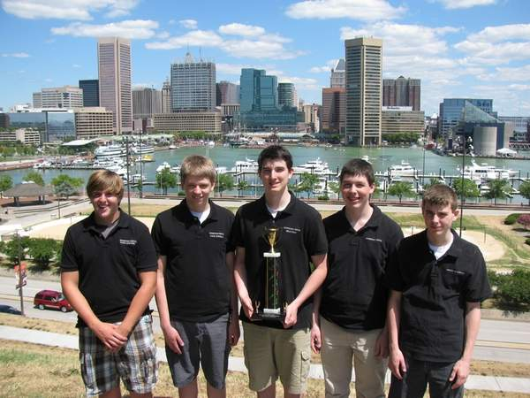
Special to The Sun

From left, David Shepard, David Sorrels, Brad King, Greg Spencer and David Spencer.
By Harriet Daniels
Staff writer
Published: Sunday, September 19, 2010 at 11:57 p.m.
Last Modified: Monday, September 20, 2010 at 12:00 a.m.

The Cornerstone Academy Robotics team competed at the Florida Technology Association State Competition in Orlando in April. Of the five events entered, the team placed first in Electronics Research category and Experimentation and Engineering Design. The team made the finals in the Systems Control Technology, Music Production, and CAD, Engineering with Animation categories.
Team members include: David Shepard, David Sorrels, Brad King, Greg Spencer and David Spencer.
The team traveled to Baltimore in July for the National Technology Student Association Conference, where they placed first in the Electronics Research and Experimentation competition.

