Electronics Technology and Robotics III
Control and Navigation 12 – Stepper Motors

- Administration:
  - Prayer
- Stepper Motors:
  - Introduction: For applications where precise measuring of a motors' rotational position is critical, a stepper motor is an excellent choice. Stepper motors operate differently from other motors; rather than voltage being applied and the rotor spinning smoothly, stepper motors turn on a series of electrical pulses to the motor's windings. Each pulse rotates the rotor by a discrete amount or “step”, hence the name "stepper motor". In this lesson, a PIC microcontroller will drive transistors in the correct order to rotate a stepper motor.

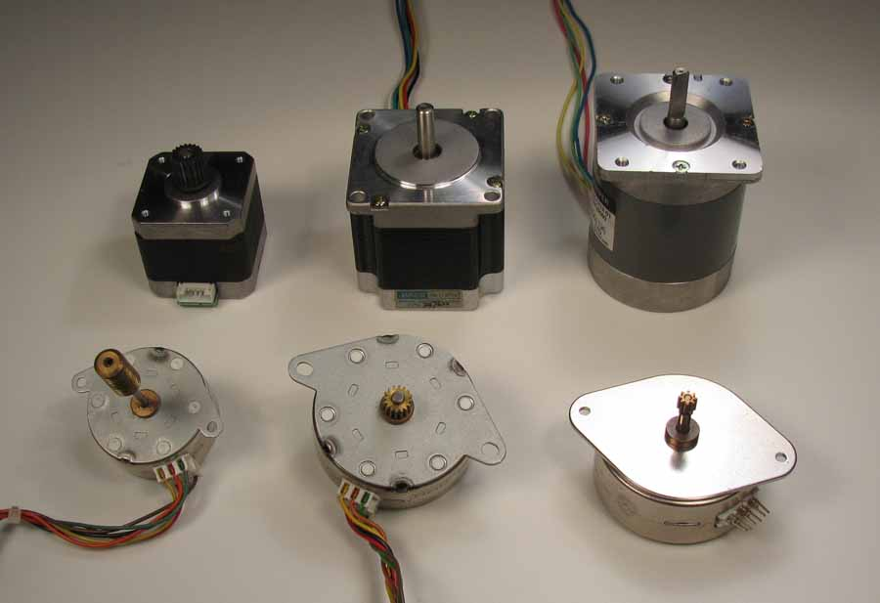

Figure 6: Several Stepper Motors of Different Sizes

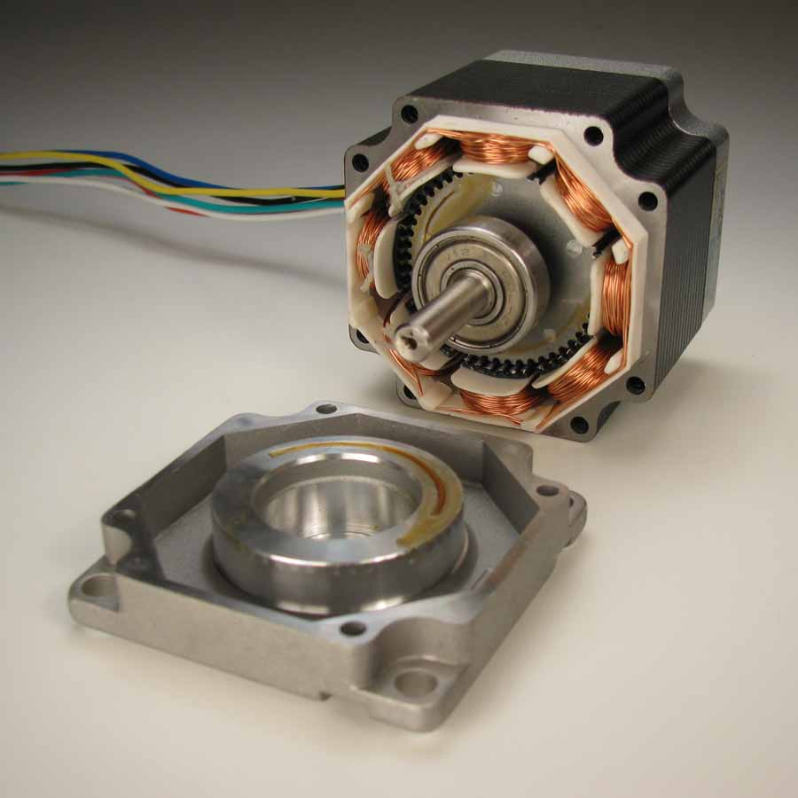

Figure 7: A Stepper Motor with the Mounting Plate Removed

  - Although there are several types of stepper motors, we will focus this presentation on unipolar stepper motors.
  - In our illustration in Figure 8, the stepper motor rotates 90 degrees in each step. In a real stepper motor, the steps are smaller; for example, the lab in this lesson uses a stepper motor with a resolution of 1.8 degrees per step or 200 steps per revolution. Although this may appear to add complexity to the process of driving the motors, the operation is identical to the simple 90 degree motor we used in our illustration.
  - Single Stepping Mode for a Simplified Unipolar Stepper Motor: the simplest mode turns one coil ON at a time. The pulse sequence for single stepping follows (Table 1): (Used in http://www.cornerstonerobotics.org/code/step_mot1.pdf)

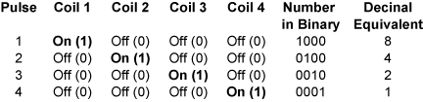
Table 1: Single Stepping Mode Pulse Sequence
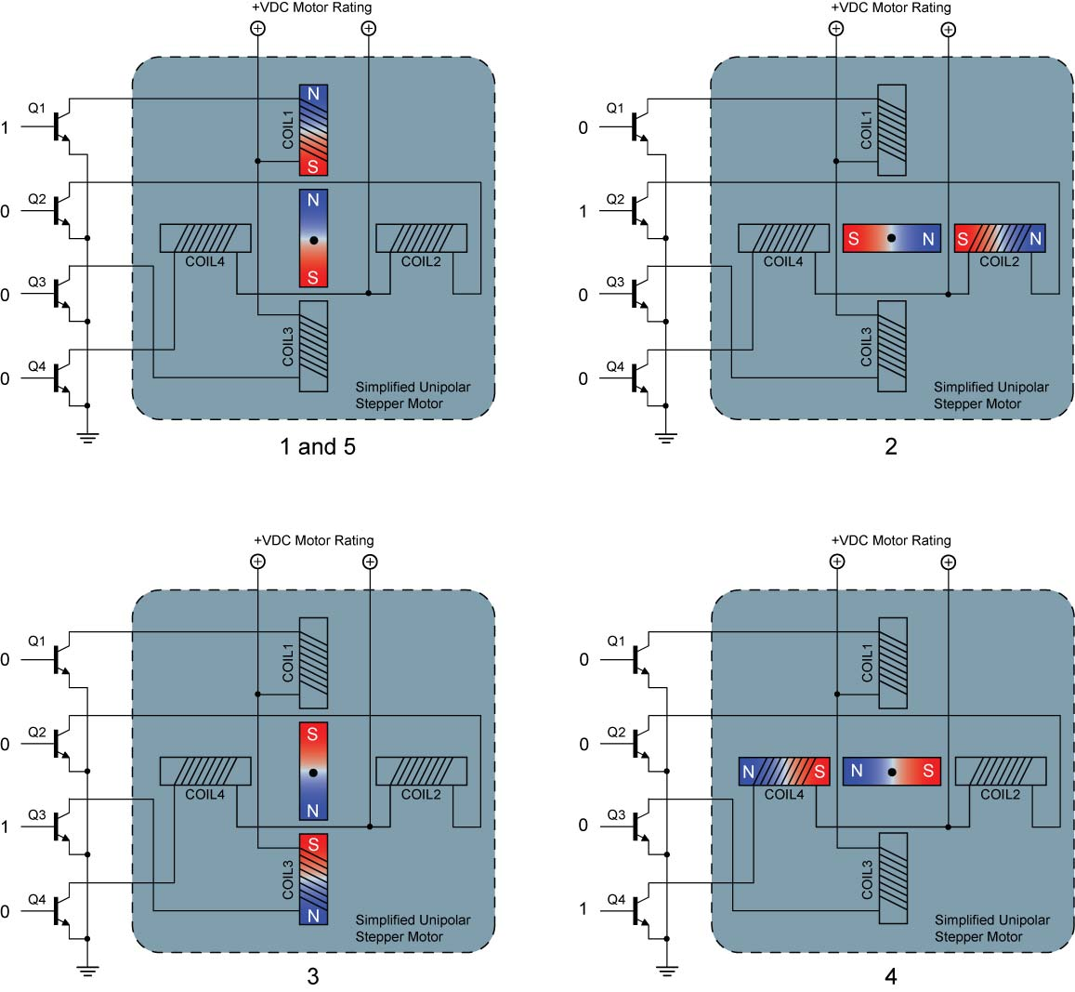
Figure 8: Single Stepping a Unipolar Stepper Motor

  - Identifying the lead configuration on a 6-lead unipolar stepper motor:
    - Unipolar motors generally have 6 leads – there are two windings with an internally connected common lead (Figure 9).

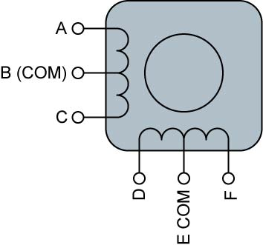

Figure 9: Wire Connection Diagram for a 6-Lead Unipolar Stepper Motor

    - If you do not have the wire configuration for the 6-lead unipolar stepper motor, you can take steps to unravel the order of the connections.
    - The resistance between the common wire and the two ends of the winding is always about half of what the resistance is between winding end to winding end (Figure 10). The resistance between Winding_{AC} and Winding_{DF} is infinite.
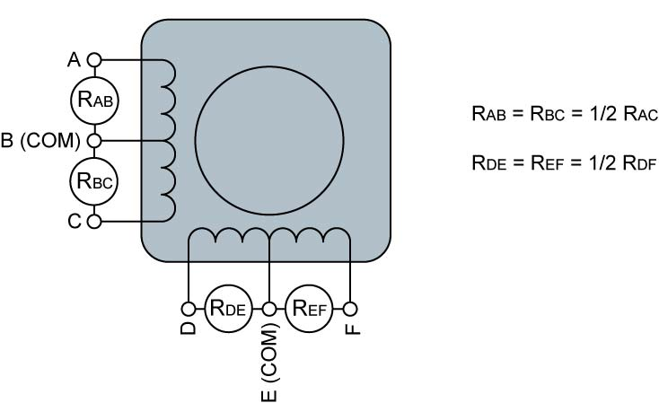

Figure 10: Winding Resistances in a 6-Lead Unipolar Stepper Motor
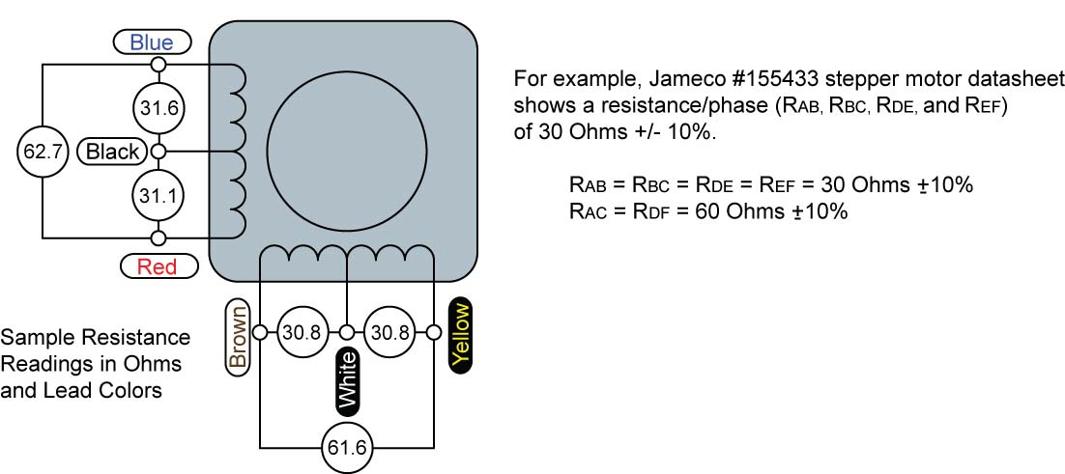

Figure 11: Sample Stepper Motor Winding Resistances
    - Now connect the two common (center tap) wires to the voltage source matching the stepper motor voltage rating (VDC Motor Rating in Figure 12).

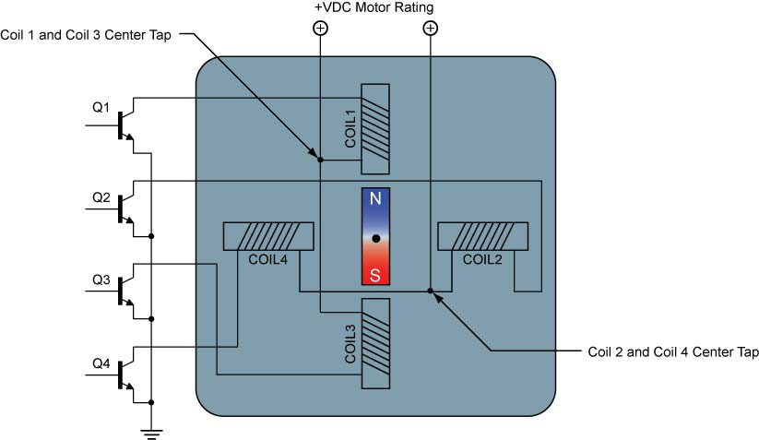

Figure 12: Connecting the Stepper Motor Leads

    - In Figure 12, notice that Coil 1 and Coil 3 make up the same coil with one center tap. Also, Coil 2 and Coil 4 make up the second coil with another center tap. We must stagger the coil ends when connecting them to the transistors; we cannot connect them to consecutive transistors.
    - To now, our Jameco stepper motor #155433 in Figure 13 has two of the six wires (black and white) connected as shown in Figure 14.
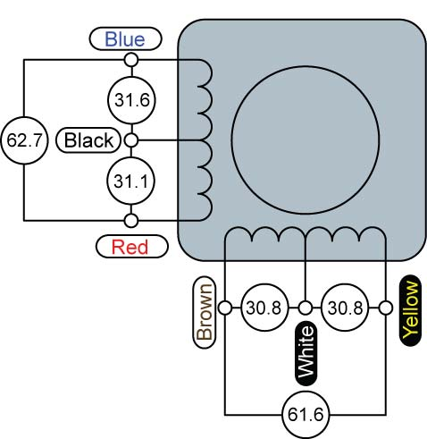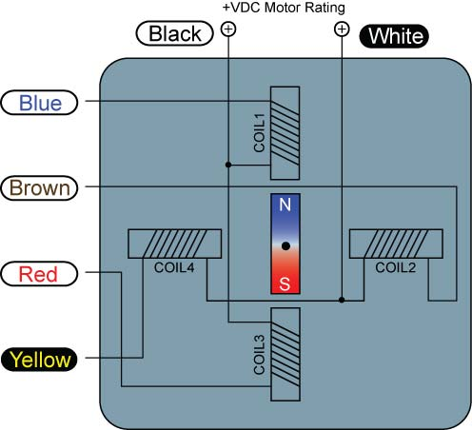

Figure 13: #155433 Stepper Resistances Figure 14: #155433 Stepper Connections
to This Point
    - Now we must connect the remaining four coil end wires to the transistors (Q1 – Q4) in the correct sequence. Q1 and Q3 are either blue or red; Q2 and Q4 are either brown or yellow. This creates the stagger we spoke of earlier. There are four possible connection sequences listed in Figure 15. If your first connection sequence does not make the motor rotate, try the other sequences until the motor spins properly.

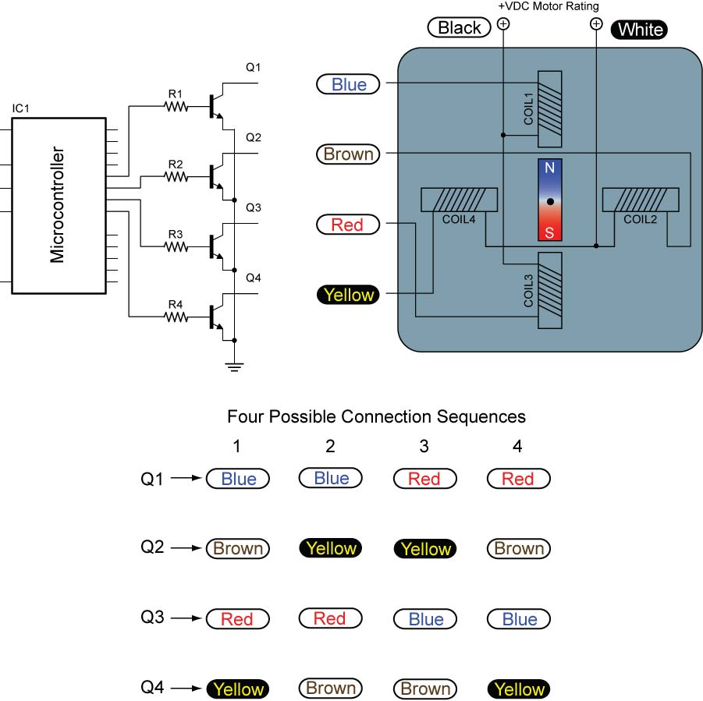

Figure 15: Possible Transistor Connections Using the Sample Motor from Figures 11 and 14

    - To reverse the direction of rotation, interchange the motor leads connected to Q1 with Q4 and Q2 with Q3.
  - Perform Control and Navigation 12 – Stepper Motors Lab 1 – Detailing Stepper Motor Windings.
  - High Torque Stepping – The high torque mode turns ON two coils on at a time. The pulse sequence for high-torque stepping follows (see Table 2): (Used in http://www.cornerstonerobotics.org/code/step_mot_hi_torque.pdf)

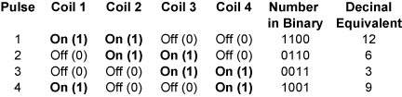
Table 2: High Torque Stepping Mode Pulse Sequence
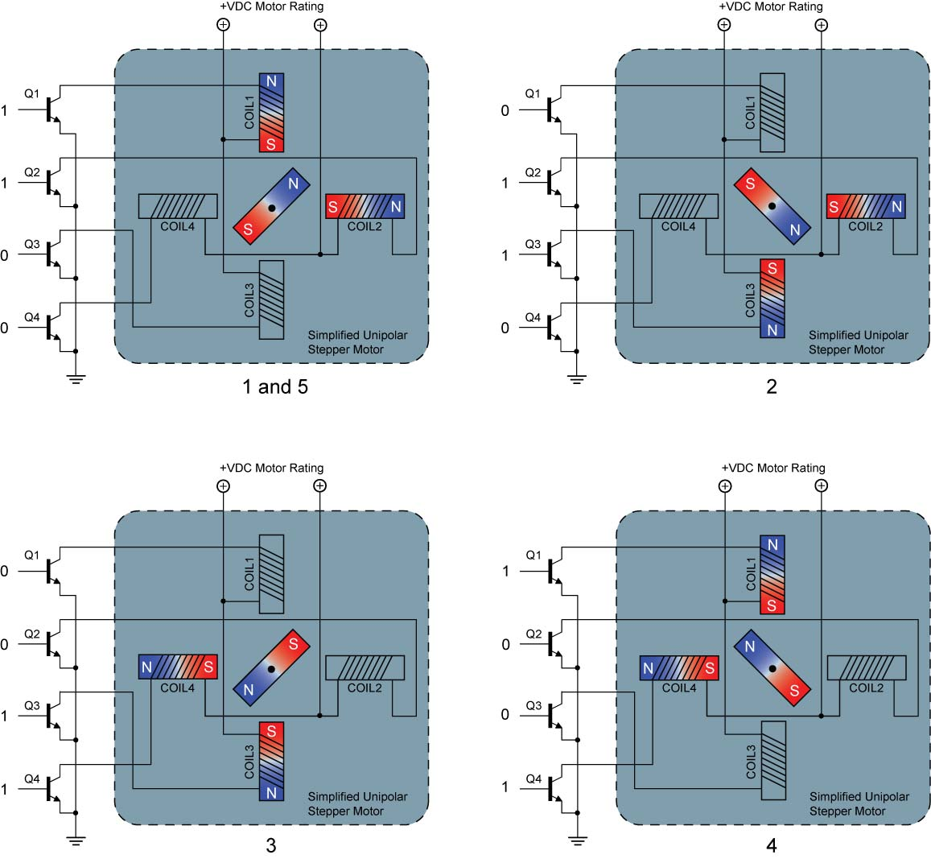
Figure 16: High Torque Stepping a Unipolar Stepper Motor
    - High torque stepping provides about 1.4 times the torque of the single stepping mode, but it requires twice the power.
  - Half Stepping – Half stepping requires double the number of pulses to complete one revolution. The pulse sequence for half stepping follows (Refer to Table 3): (Used in http://www.cornerstonerobotics.org/code/step_mot_half_step.pdf)

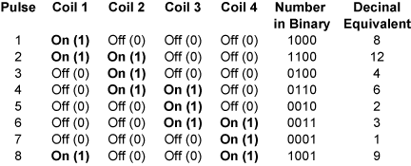
Table 3: Half Stepping Mode Pulse Sequence
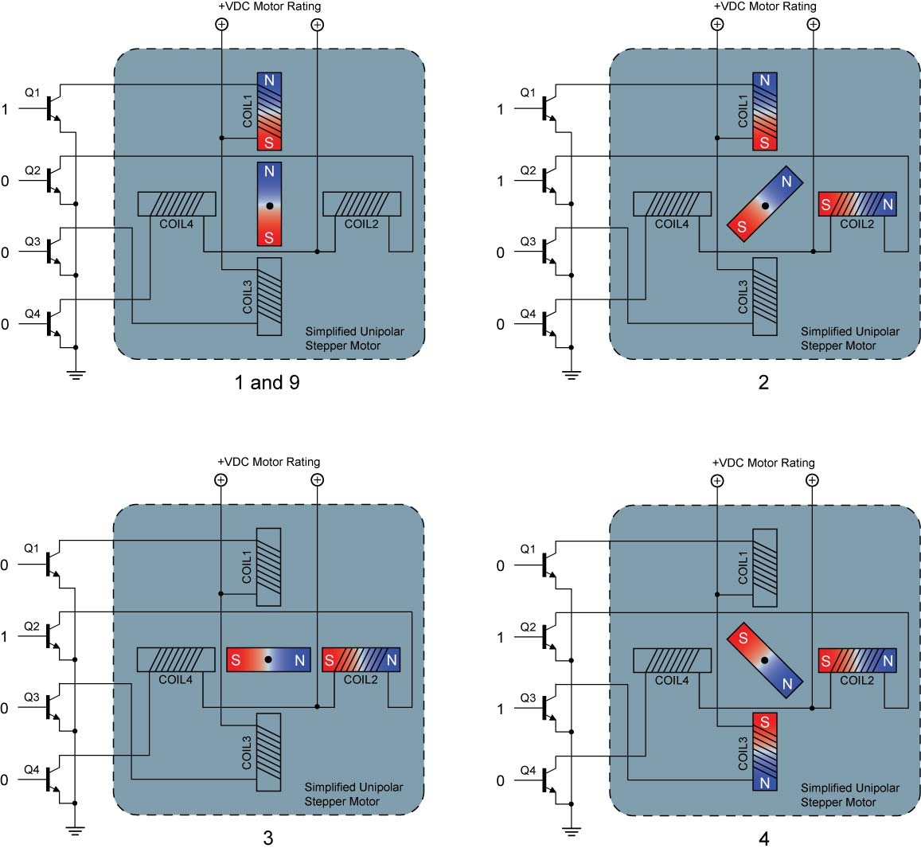

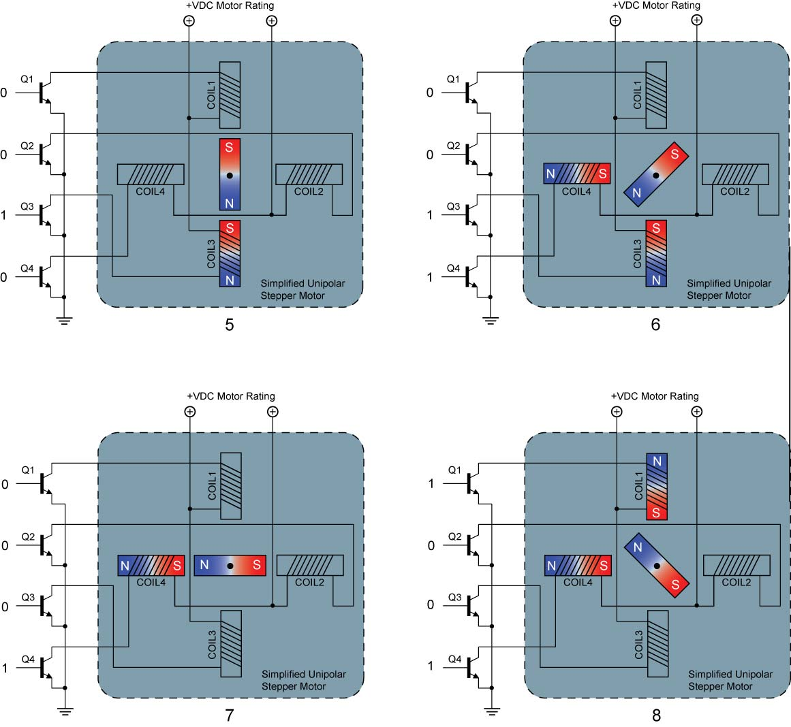
Figure 17: Half Stepping a Unipolar Stepper Motor
  - Perform Control and Navigation 12 – Stepper Motors Lab 2 – Making a Stepper Motor Turn.
- Other Web Site References:

Electronics Technology and Robotics III
Control and Navigation 12 – Stepper Motors Lab 1 – Detailing Stepper Motor Windings

- Purpose: The purpose of this lab is to figure out how to hook up a 6-lead unipolar stepper motor to a microcontroller when a datasheet is unavailable.

- Apparatus and Materials:
  - 1 – Breadboard with +5V Power Supply and a Power Supply Matching the Voltage Rating of the Stepper Motor. Note: The stepper motor power supply must be sufficiently robust for the motor to rotate properly.
  - 1 – Ohmmeter
  - 1 – Jameco #237543 or #162027 12V Unipolar Stepper Motor or Equivalent
  - 1 – PIC16F88
  - 1 – 4.7K Resistor
  - 4 – 1K Resistors
  - 4 – TIP 120 NPN Darlington Transistors

- Procedure:
  - Before hooking up the leads to the stepper motor, we must first determine how the leads are interrelated. We do this by measuring the resistances of the windings.
  - As stated in the lesson, the resistance between the common wire and the ends of the winding is always about half of what the resistance is between winding end to winding end.

  - Use an ohmmeter to measure the resistance between all the leads of a 6-lead unipolar stepper motor. Group the colored wires that have mutual or related measurements. In the results, fill in the table similar to the one below. Circle the common lead in each winding.

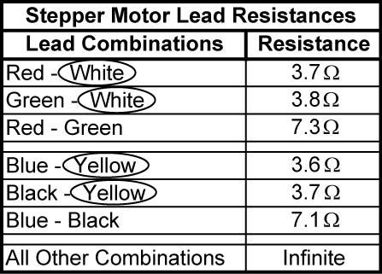
  - Now transfer the data from the resistance table to the stepper motor drawing in results. Put the resistances in the light yellow circles and the wire colors in the light green rounded rectangle.
  - Wire the circuit below and program the PIC16F88 with step_mot1.pbp. Do not make the four stepper motor connections to the TIP120 transistors.
  - Now we can connect the stepper motor leads to the PIC driver circuit.
    - First, the two common leads are both connected to a power source equal to the voltage rating of the stepper motor. See the stepper_motor1_lab1 schematic below.
    - The other four leads are connected to the TIP 120 transistors. Refer to Figure 15 for the four possible connection sequences. With the program running, try each sequence until the motor rotates properly.

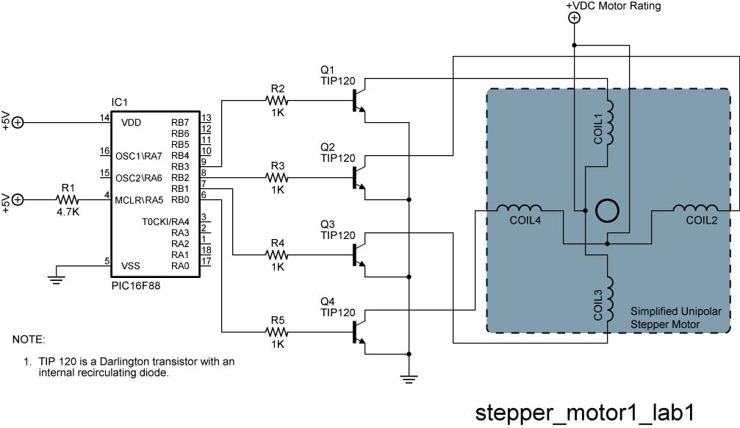

    - The stepper motor will rotate in a clockwise or counter-clockwise direction. Record the original direction of rotation.
    - To reverse the direction of rotation, interchange the motor leads connected to Q1 with Q4 and Q2 with Q3. Record the new direction.
- Results:
  - Lead Combination Resistances:

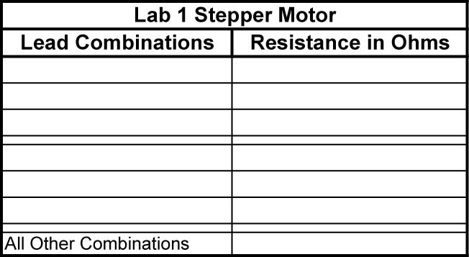

  - Stepper Motor Drawing:

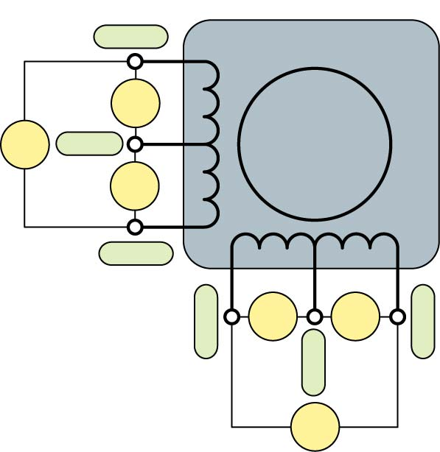

  - Direction of Rotation:

    - The original direction of the motor rotation: ____________________

    - The direction of the motor rotation after interchanging leads Q1 with Q3 and Q2 with Q4: _________________________

Electronics Technology and Robotics III
Control and Navigation 12 – Stepper Motors Lab 2 – Making a Stepper Motor Turn

- Purpose: The purpose of this lab is to drive a unipolar stepper motor with a PIC microcontroller programmed in PicBasic Pro.

- Apparatus and Materials:
  - 1 – Breadboard with +5V Power Supply and a Power Supply Matching the Voltage Rating of the Stepper Motor. Note: The stepper motor power supply must be sufficiently robust or the motor will not rotate properly.
  - 1 – Jameco #237623 Unipolar Stepper Motor or Equivalent (#155433 – 12V, 400mA, 1.8 Degrees per Step)
  - 1 – Extech # 461895 Combination Contact/Photo Tachometer
  - 1 – PIC16F88
  - 1 – 4.7K Resistor
  - 4 – 1K Resistors
  - 4 – TIP 120 NPN Darlington Transistors

- Procedure:
  - Wire the stepper_motor1 circuit below.
  - Program the PIC16F88 with step_mot1.pbp.
  - Change the values of Delay and note the change in rpm.
  - Set the value of Delay to 250 and count the number of steps the motor takes to complete one revolution. From number of steps/revolution, calculate the angle in degrees of each step. Record your results.
  - Program the PIC16F88 with step_mot_hi_torque. Compare the new torque generated with that generated in step_mot1.pbp.

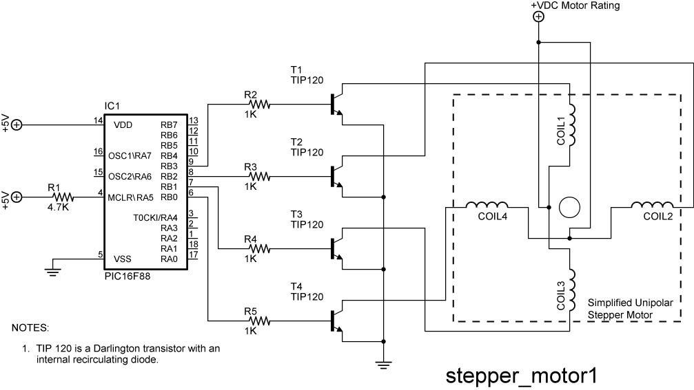

- Results:
  - Delay vs. RPM:

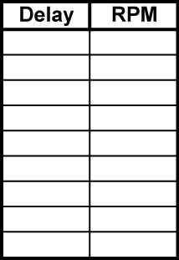

  - Number of Steps/Revolution:

Number of steps per revolution = ____________steps.

One revolution = __________ degrees.

The angle in degrees of each step = __________ degrees/step.

- Challenge:
  - Create a program called step_motor_1_sec.pbp such that the stepper motor makes one revolution per second. First calculate the time for each step.
  - Now write a program named step_motor_1_rev.pbp so that the stepper will make only one revolution then stop. Knowing the number of steps in one revolution, use a FOR…NEXT loop to solve the challenge.
  - Write a program named step_motor_reverse.pbp so that makes the stepper motor make one revolution with each step taking 3 ms, then reverse direction and rotate for one revolution with each step lasting 10 ms.

