Electronics Review 1
Cornerstone Electronics Technology and Robotics II Week 1

- Administration:
  - Prayer
  - Welcome back
  - Review Quiz 1
- Review:
  - Reading meters:
    - When a current or voltage value is unknown, begin with the highest meter range.
    - An ammeter must always be connected in series (in line) with a circuit component.
    - Voltmeters are always connected in parallel with the component (across the component).
    - When measuring resistance, disconnect the resistor from the circuit. Also make sure power is off to the circuit.
  - Ohm’s Law:

V = I x R where:

V = voltage in volts,
I = current in amperes, and
R = resistance in ohms
  - Switches:
    - SPST switch example and symbol: 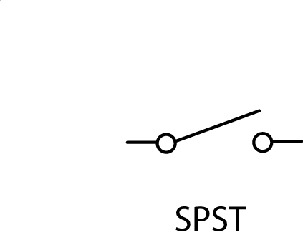

    - SPDT switch example and symbol:
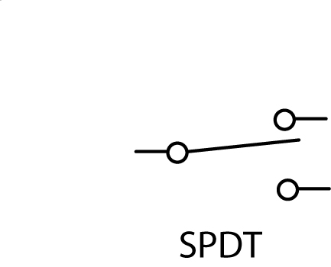

    - DPDT switch example and symbol:
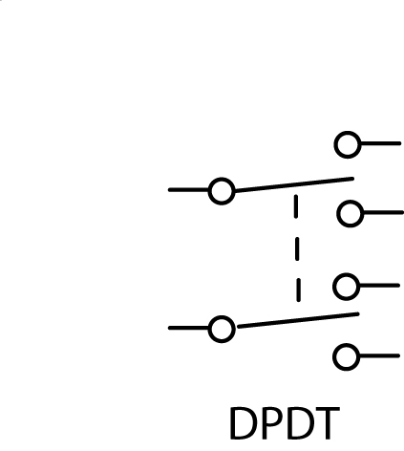

    - Momentary switches:

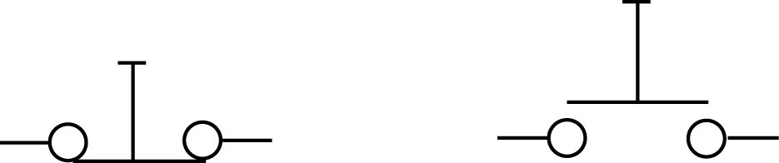

Normally Closed (NC) Normally Open (NO)

    - Show samples
  - Potentiometer: a 3 -Terminal Variable Resistor
    - 100 Watt sample
    - Potentiometer Symbol:

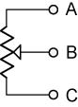
    - Function:

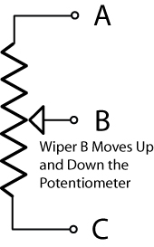

Potentiometer

      - The resistance between points A and C (R_{AC}) is constant. It is the resistance rating of the potentiometer.
      - As wiper B moves up and down the potentiometer, resistances R_{AB} and R_{BC} vary, but R_{AB} + R_{BC} will equal R_{AC}.
      - Set up an experiment to verify the last point.

  - Rheostat: A 2 -Terminal Variable Resistor
    - Symbol:

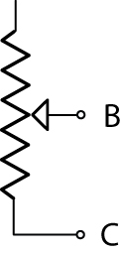

Rheostat

    - Potentiometer Wired as a Rheostat:

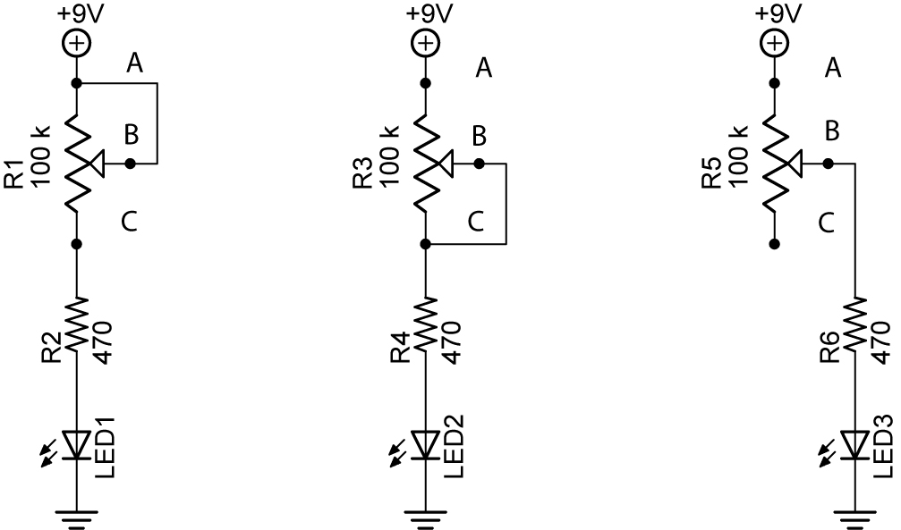

Circuit A Circuit B Circuit C

      - In the Circuits A and B above, a potentiometer is used as a rheostat.
      - In Circuit A above, R_{AB} is always 0 Ohms and R_{BC} varies from 0 – 100K Ohms.
      - In Circuit B, R_{BC} is always 0 Ohms and R_{AB} varies from 0 – 100K Ohms.
      - In Circuit C, R_{AB} varies from 0 – 100K Ohms and R_{BC} does not exist since there is no connection to C.
      - What is the purpose of the 470 ohm resistor?
  - Review Summary Sheet of Series and Parallel Circuits
    - See: http://www.cornerstonerobotics.org/curriculum/lessons_year1/ER%20Week13a,%20Series%20Parallel%20Summary.pdf
  - Parallel Resistors:
    - Perform Review 1 Lab 1 – Voltage Drop in a Parallel Circuit

  - Voltage Dividers:
    - Series resistors can be used to divide a voltage into smaller voltages. For example, the following series resistors divide a 12 volt source into 12 volts, 8 volts, and 4 volts using the same value for each resistor. Notice that we are not measuring voltages across each resistor, but voltages from a point, e.g. B to the ground point D (V_{BD}). (The voltage drop across each individual resistor is 4 volts.)

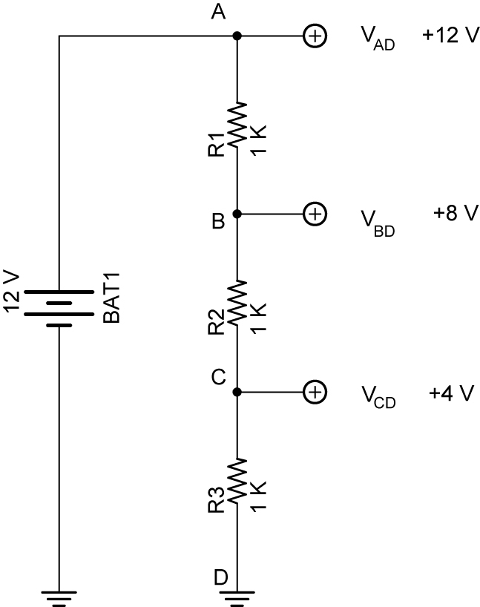

Example of a Voltage Divider

    - Potentiometers can be used as voltage dividers. In the circuit below, the sum of the voltmeter measurements V_{AB} and V_{BC} equals the source voltage V_{AC}.

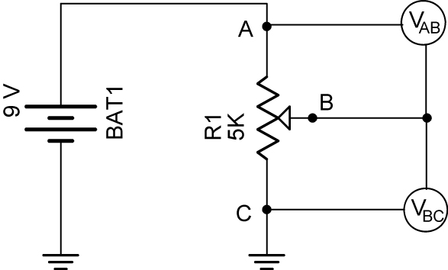

Potentiometer as a Voltage Divider

    - Voltage dividers may be used in resistive sensor circuits
    - Perform Review 1 Lab 2 – Potentiometers.

  - Kirchhoff’s Current Law: The sum of the currents into a junction is equal to the sum of the currents leaving that junction.
    - Parallel circuits act as current dividers.

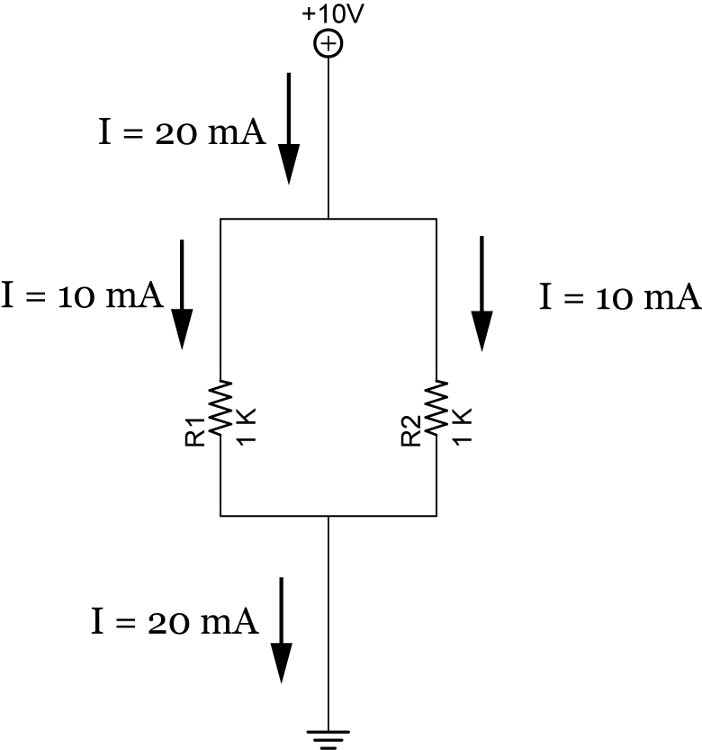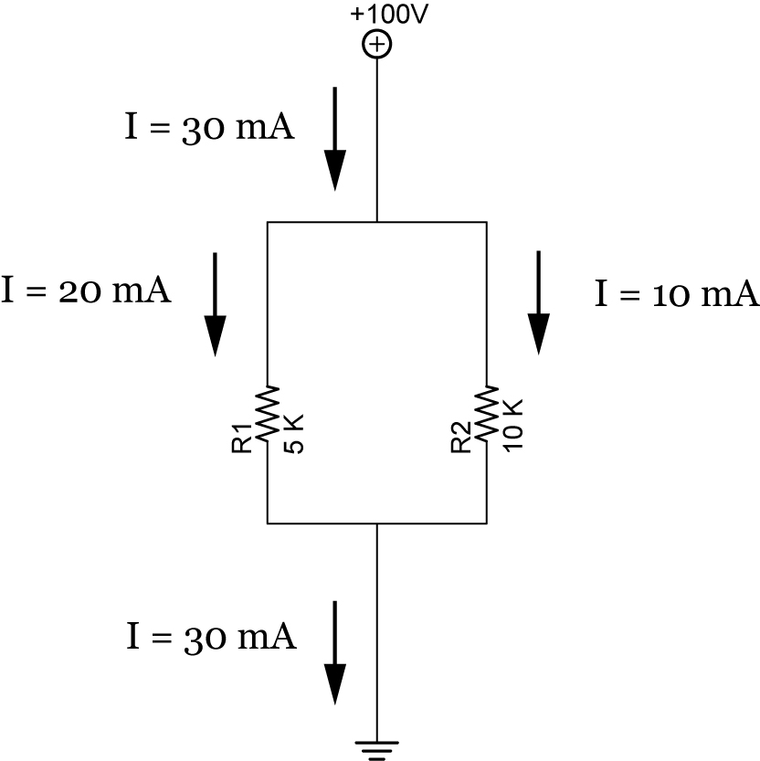

Example 1 Example 2

- 14” Band Saw:
  - Safety Rules:
    - See copy from the manual.
  - Operation:
    - See copy from the manual.
- Project for the Year:
  - Each student will design and build his own mobile autonomous robotics car. The car must be equipped to:
    - Use dc motors as the drive system
    - Have sufficient room on a breadboard for a LCD (Liquid Crystal Display), PIC microcontroller(s), H-bridge, and other supporting electronics
    - Mount several different sensors that will be studied this year
- Practice Circuit:
  - Perform Review 1 Lab 3 – Touch Switch.

Cornerstone Electronics Technology and Robotics II Week 1
Electronics Review 1 Lab 1 – Voltage Drop in a Parallel Circuit

- Purpose: The purpose of this lab is to experimentally verify that the voltage drops across parallel resistors are equal.

- Apparatus and Materials:

  - 1 – Solderless Breadboard with 9 V Power Supply
  - 1 – Digital Multimeter
  - 1 – 1 K Ohm Resistor
  - 2 – 2.2 K Ohm Resistors
  - 1 – 4.7 K Ohm Resistor

- Procedure:
  - Wire the following circuit
  - Measure and record V_{AE}, V_{BF}, V_{CG}, and V_{DH}.

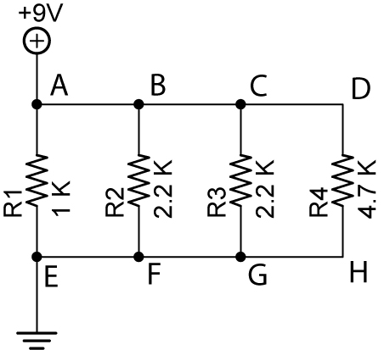

- Results:

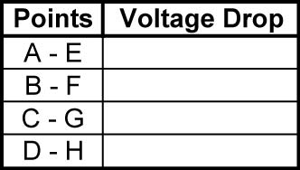

- Conclusions:
  - How do the voltage drops V_{AE}, V_{BF}, V_{CG}, and V_{DH} mathematically relate to each other?

Cornerstone Electronics Technology and Robotics II Week 1
Electronics Review 1 Lab 2 – Potentiometers

- Purpose: The purpose of this lab is have the student measure tripot values and to help the student understand the function of a potentiometer as a variable resistor.

- Apparatus and Materials:

  - 1 – Digital Multimeter
  - 1 – 5 K Ohm Potentiometer

- Procedure:
  - Testing potentiometers:
    - Test and record the maximum resistance of the potentiometer with a DMM, and compare with value printed on the side of the potentiometer.
    - Turn the potentiometer shaft and then flip the DMM leads. How does the maximum resistance value of the potentiometer react? Record your results.
    - Using the DMM, measure and record the resistance R_{AB}, R_{BC}, and R_{AC} at three different positions of the potentiometer. Before changing each position, apply +5v to Point A and ground to Point C, then measure and record V_{AB}, V_{BC}, and V_{AC}.

- Results:

  - Maximum resistance of the potentiometer:

Maximum resistance = _______________ohms

Printed value of the potentiometer = ______________ ohms

Resistance when potentiometer shaft turned = _________ohms

Resistance when DMM leads reversed = _____________ohms

  - Testing potentiometers:

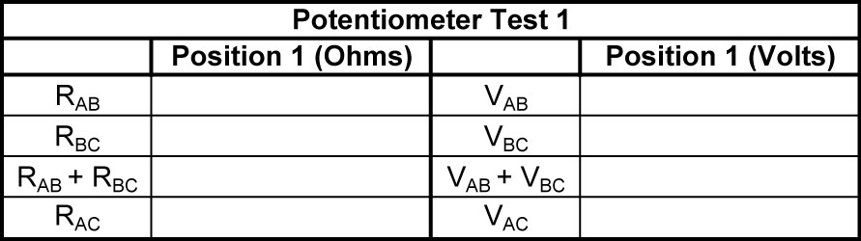

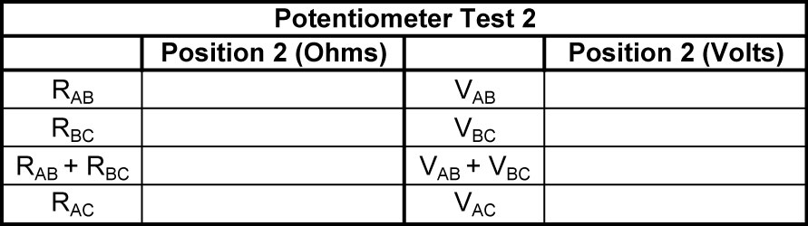

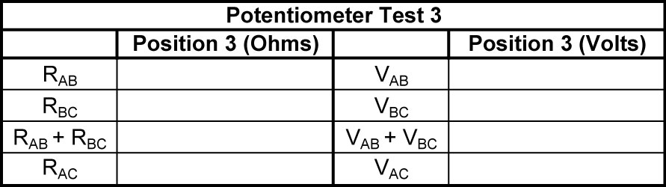

- Conclusions:
  - In the potentiometer test, mathematically relate R_{AC} to R_{AB} and R_{BC}.

  - How does V_{AC} relate to V_{AB} + V_{BC}?

Cornerstone Electronics Technology and Robotics II Week 1
Electronics Review 1 Lab 3 – Touch Switch

- Purpose: The purpose of this lab is to reacquaint the student with wiring a circuit on a breadboard.

- Apparatus and Materials:

  - 1 – 555 Timer
  - 1 – 10M Ω Resistor
  - 1 – 100K Ω Resistor
  - 1 – 1K Ω Resistor
  - 1 – 0.01 uF Capacitor
  - 1 – 4.7uF, 10uF, 22uF, 47uF, and 100uF Capacitors
  - 1 – LED

- Procedure:
  - Wire the touch switch circuit on your breadboard.
  - Use a 4.7 uF capacitor for C2 to begin, and then substitute the 10 uF, 22 uF, 47 uF, and 100 uF in its place.
  - Use the normal jumpers as your touch leads.



