Cornerstone Electronics Technology and Robotics I Week 6
Batteries and Other Energy Sources

- Administration:
  - Prayer
  - Review: Calculate then measure the current passing through a resistor.
  - Review: Using a tripot, make a circuit such that one LED dims as a second LED brightens. Don’t forget a 470 ohm resistor in case the tripot is at 0 ohms.
- Introduction:
  - Six basic sources of electricity or electromotive force:
    - Friction (covered in Week 1, Statics)
    - Chemical Action (this week’s topic)
    - Light (this week’s topic)
    - Heat (this week’s topic)
    - Pressure (this week’s topic)
    - Magnetism (not covered)
- Chemical Action:
  - Volta discovered that when two dissimilar elements were placed in a chemical that reacted upon them, an electrical potential was built up between them.
  - A simple cell consists of two dissimilar metal electrodes with different charges (positive and negative) in a liquid or paste electrolyte solution that contains free floating ions This combination allows for the transfer or exchange of electrons between the electrodes. A battery stores chemical energy, which it converts to electrical energy.
  - Perform Batteries and Other Energy Sources Lab 1 – Hand Battery
  - Cells and Batteries:
    - A cell is a single unit that produces a direct current voltage by converting chemical energy into electrical energy. Symbol:

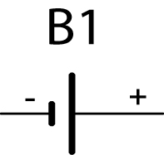

    - A battery is a dc voltage source made up of two or more cells. Symbol:
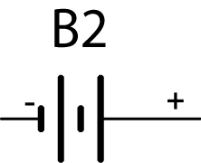

    - For example, 6 - 1.5 volt alkaline batteries connected in series make up a 9 volt battery. See the photographs below.

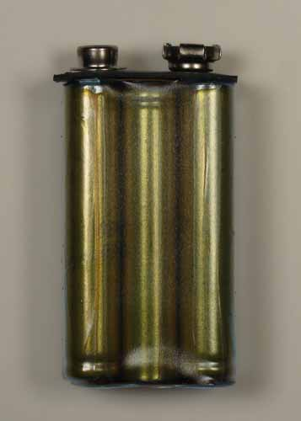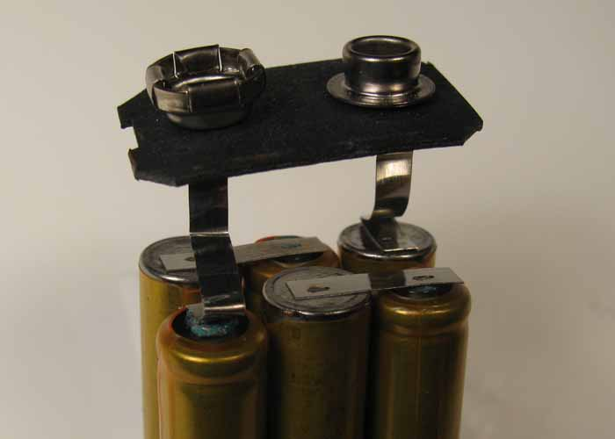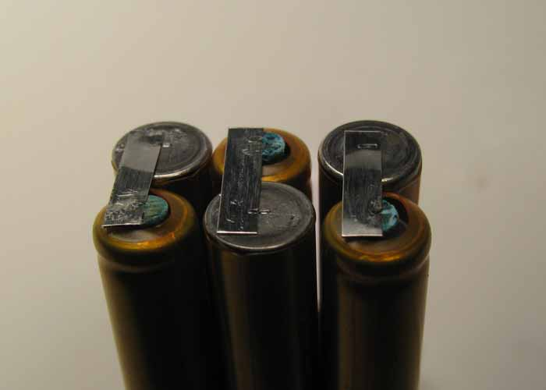

1.5 Volt Cells Are Connected in Series to Form a 9 Volt Battery
  - Batteries in a Circuit:
    - In an electrical circuit, a battery creates a surplus and a lack of electrons through a chemical reaction. The surplus terminal is the (–) terminal and the lacking terminal is the (+) terminal. Attraction and repulsion forces are exerted on the free electrons causing them to move and thus current is created. Remember that unlike charges attract and like charges repel.
    - Unless electrons are flowing from the negative to the positive terminal, the chemical reaction does not take place. Once you connect a wire, the reaction starts. That is why a battery can sit on a shelf for an extended period of time and still have plenty of power.
  - Primary Cells:
    - A primary cell is an electric cell that produces electric current through a chemical reaction which cannot be reversed; a primary cell cannot be recharged.
    - Primary cells are also called dry cells. A dry cell is a cell in which the electrolyte is absorbed into a paper or made into a paste.

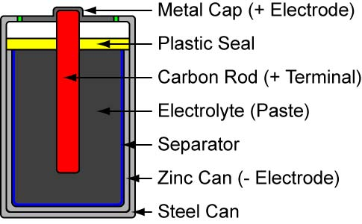

Primary Battery Construction (Carbon-Zinc Battery)

    - A battery or generator is like your heart: it moves blood, but it does not create blood.
    - Types of primary cells:
      - Carbon-zinc cell,1.5v, the standard carbon battery, (carbon and zinc electrodes with an acidic paste electrolyte)
      - Alkaline cell, 1.5v, the Duracell and Energizer batteries, (zinc and carbon electrodes and an alkaline electrolyte)
      - Mercury cell, 1.3v, (mercuric oxide and zinc electrodes and potassium hydroxide electrolyte)
      - Lithium cell, 3.0v, (two mixtures, one-lithium, and two-iron sulfide)
      - Silver oxide cell, 1.5v, (zinc and silver oxide electrodes), this cell is used in aeronautical applications because the power-to-weight ratio is good.
  - Secondary cells
    - A secondary cell is an electric cell that produces electric current through a chemical reaction which can be reversed; a secondary cell can be recharged.
    - A secondary cell can be recharged by forcing a current through the battery in the opposite direction of the discharge current.
    - Chemical formulas for lead-acid battery charging: http://openbookproject.net//electricCircuits/DC/DC_11.html
    - Types:
      - Lead acid cell, 2.0v, used in automobiles, (lead oxide and lead electrodes and sulfuric acid in water electrolyte)

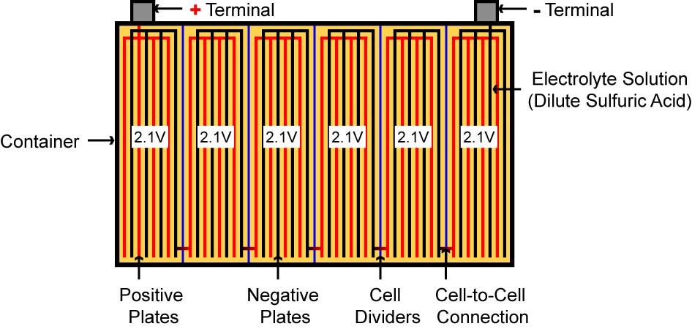

12.6 Volt Lead-Acid Car Battery Internal Connections

      - Nickel-cadmium cell, 1.2v,(nickel salt and cadmium salt plates with a potassium hydroxide electrolyte)
      - Nickel-metal hydride battery - This battery is rapidly replacing nickel-cadmium because it does not suffer from the memory effect that nickel-cadmiums do.
  - Safety considerations:
    - Hazards associated with industrial lead-acid batteries:
      - Hydrogen gas
        - Lighter than air
        - Flammable by nature, explosive
        - Can not taste or smell gas vapors
      - Sulfuric acid
        - Burns skin and eyes
      - Shock
      - Weight of the battery
    - Show photo of battery after explosion: http://www.rayvaughan.com/battery_safety.htm
    - Maintenance-free batteries rely on valves fitted to each cell. Normally any hydrogen and oxygen produced in the cell will recombine into water, but malfunction or misuse may cause gas to build up inside the cell. If this happen (e.g. by overcharging the cell) the valve is designed to vent the gas and thereby normalize the pressure, resulting in a characteristic acid smell around the battery. However, if the valve fails (e.g. blocked by dirt or debris) a dangerous pressure can build up inside the cell. A slight jolt can make a spark jump between the posts and ignite the gas causing an explosion. The force is sufficient to burst the plastic casing or blow the top off the battery, and can injure anyone in the vicinity and spray acid and casing shrapnel to the immediate environment. As a warning, swelling in the cell walls of the battery will occur when the internal pressure rises. The deformation of the walls varies from cell to cell, and is greater at the ends where the walls are unsupported by other cells. It is surprising how powerful an explosion can be caused in the small air space above the electrolyte. When one cell explodes, it sets off a chain reaction in the rest. Such over pressurized batteries should be isolated and discarded, taking great care using protective personal equipment (goggles, overalls, gloves etc) during the handling. From: http://www.answers.com/topic/lead-acid-battery-1?cat=technology
    - Wear personal protection equipment.
      - Safety goggles
      - Rubber gloves
      - Face shield
      - Rubber apron
    - Never open the battery caps with face directly over the battery.
    - Keep sparks and flames away from the battery. Smoking or open flames should never be present in a battery area. Inspect the battery in natural light.
    - Charge batteries in well ventilated space.
    - Keep tools and other metallic objects away from uncovered batteries. Never lay tools across the top of a battery. Only use non-conducting tools to remove battery caps.
    - Remove wrist watches, rings, and jewelry which might make electrical contact and create sparks.
    - Wear safety goggles and face shield when working with batteries.
    - If acid does enter the eye, immediately flood with running water for at least 30 minutes. See a doctor as soon as possible.
    - If acid contacts the skin, wash immediately with plenty of water.
    - Do not rub eyes or skin while working with the battery.
    - Wash your hands immediately after completing the job.
    - Clean up all acid spills and flush clothing with a water and baking soda solution.
    - Keep batteries away from children.
    - Store batteries in a cool, dry place. Storage temperature should be between 80ºF and 32ºF.
    - Don't make live connection directly to the battery. Explosive gases can be set off by a match, incorrect connection of battery cables, and careless use of tools around the battery.
    - Use proper lifting techniques when moving batteries. Batteries are small, but heavy and awkward to lift.
    - See: http://siri.uvm.edu/ppt/batterysafety/sld001.htm
  - Batteries in series:
    - Schematic:

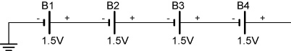

    - Voltages are added:

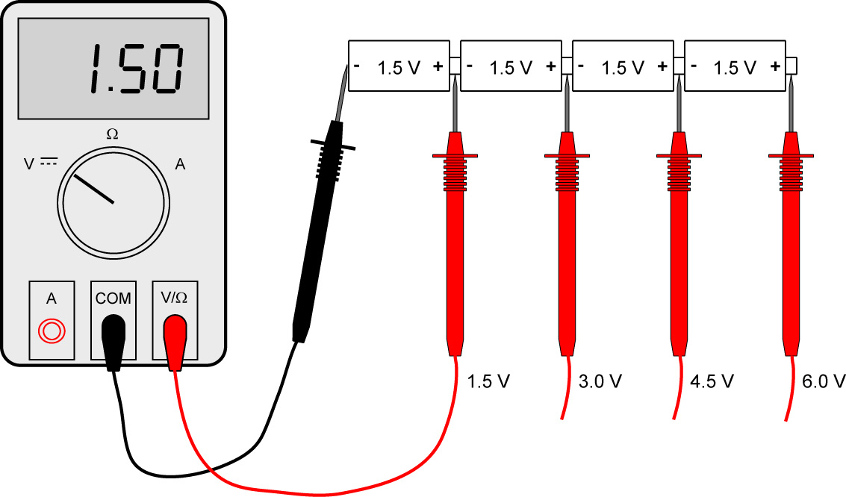

DMM Test Leads Shows Voltages at Several Points for Batteries in Series

    - Amperage is the same
  - Batteries in parallel:
    - Schematic:

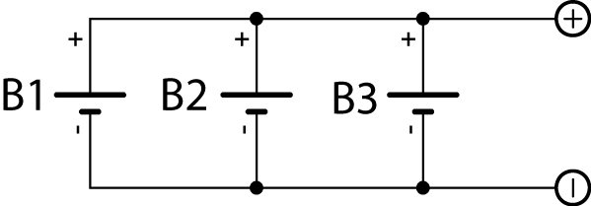

    - Voltage is the same:

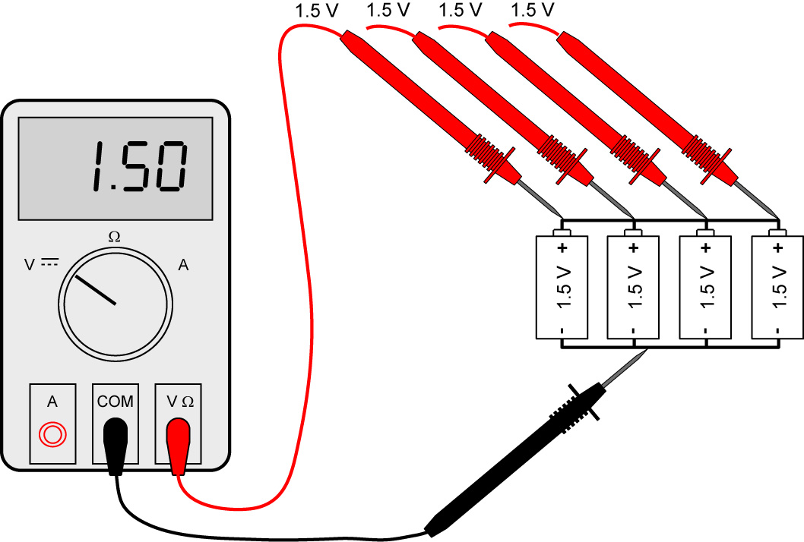

DMM Test Leads Shows Voltages at Several Points for Batteries in Parallel

    - Amperage is added
  - Batteries in series and parallel:
    - Example schematic:

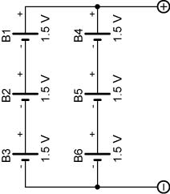

Batteries in Series and Parallel

    - Example of hook up:

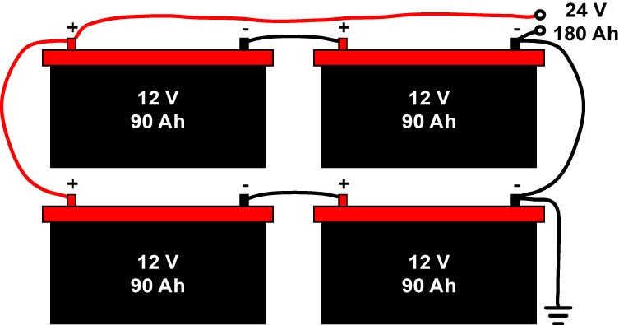

    - The voltages across B1, B2, and B3 are added since they are in series to get 4.5 V. The voltages across B4, B5, and B6 are also added (4.5 V).
    - Since the group B1, B2, and B3 is parallel with the group B4, B5, and B6, the amperages of the two groups add.
    - Perform Batteries and Other Energy Sources Lab 2 – Series and Parallel Batteries
  - Combining Batteries to Supply a Negative Voltage:
    - Many circuits require both a positive and negative voltage supply. An audio circuit is such a circuit in that its signals vary between positive and negative voltages relative to the 0 volts reference.
    - The positive and negative voltages can be generated by repositioning the ground between two batteries in series. See the example below.

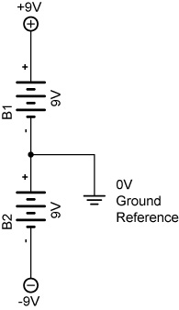

Combining Batteries to Supply a Positive and Negative Voltage

  - Battery Capacity:
    - The capacity of a battery is its ability to produce a current over a certain period of time.
    - Because of their limited source of chemical energy, batteries have a limited amount of time they can produce power.
    - Capacity is measured in ampere-hours (Ah) and milliampere-hours (mAh). The ampere-hour rating determines the length of time that battery can deliver a certain amount of current to a load at the rated voltage.
    - A rating of 1 ampere-hour means that the battery can deliver 1 ampere of current to a load for 1 hour at the rated voltage.
    - Ah = Current x Number of Hours
      - Example: How many hours can a battery deliver 7 amperes to a load if the battery has a 56 ampere-hour rating?

Hours = Ah Rating/Current
Hours = 56 Ah / 7 A
Hours = 8 hours

      - Another Example,

1 amp-hour = 1 amp x 1 hour
1 amp-hour = 5 amp x 0.2 hour
1 amp-hour = 10 amp x 0.1 hour

    - Samples:
    - Approximate amp-hour capacities of some common batteries are given here:
      - Typical automotive battery: 70 amp-hours @ 3.5 A (secondary cell)
      - D-size carbon-zinc battery: 4.5 amp-hours @ 100 mA (primary cell)
      - 9 volt carbon-zinc battery: 400 milliamp-hours @ 8 mA (primary cell)
  - Related web sites:
    - http://www.allaboutcircuits.com/vol_6/chpt_3/16.html
    - http://www.allaboutcircuits.com/vol_1/chpt_11/index.html

- Other Sources of Electrical Energy:
  - Electrical Energy from Light:
    - Two forms of solar energy conversion:
    - Solar thermal, that is, thermal systems (hot water, pool heaters) produce heat from the sun’s radiation at 40% efficiency.
    - Photovoltaic (photo = light; voltaic = produces voltage) systems convert light directly into electricity using semiconductor technology at about 10% efficiency.
      - As long as there is light shinning into the cells, there are electrons flowing out of the cells. The cells do not “use up its electrons and loose power, like a battery. It is just a converter, changing one kind of energy (sunlight) into another (flowing electrons or electrical). For every electron that flows out of the wire connected to the front of a cell, there is another electron flowing into the back from the other wire.
      - Demonstrate using a 10 watt solar panel.
      - Each cell only produces about ½ volt, and a module usually needs to charge a 12 volt battery or to run motors. A typical module has 36 cells connected in series to increase the voltage. 36 times ½ volt equals 18 volts. However, the voltage is reduced as the cells get hot in the sun and 12 volt batteries typically need about 14 volts for a charge, so the 36 cell module has become the standard for the solar battery charger industry.

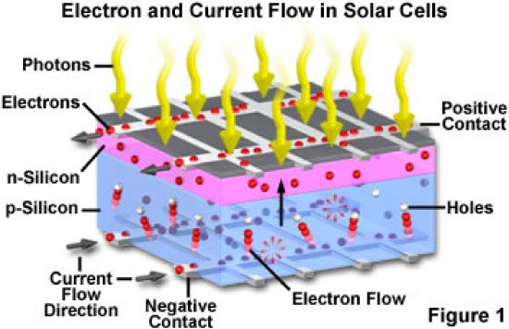
  - Types of Photovoltaic Systems:
    - Systems for Day Direct Current (DC) Use:

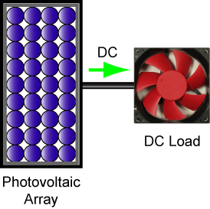

Day Use

    - System for Cloudy Weather and Night DC Use:

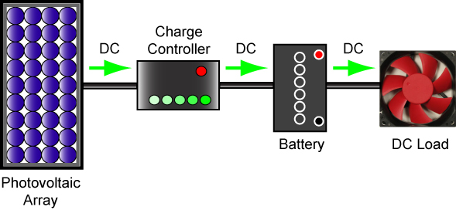

DC System with Storage Battery

    - System for Cloudy Weather and Night DC and AC Use:

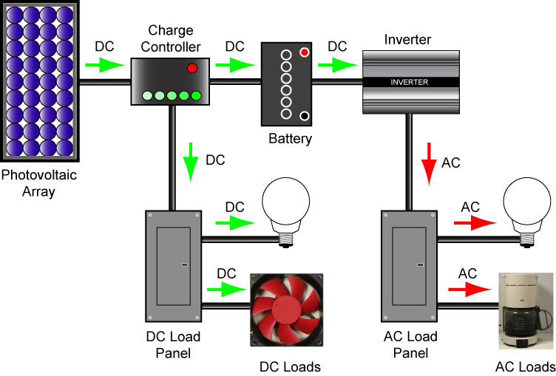

DC and AC System
  - Photovoltaic Panels in Series and Parallel:

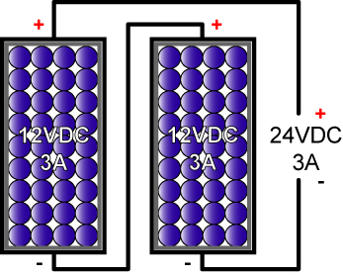

Solar Panels in Series

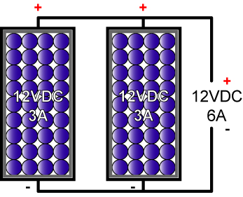

Solar Panels in Parallel

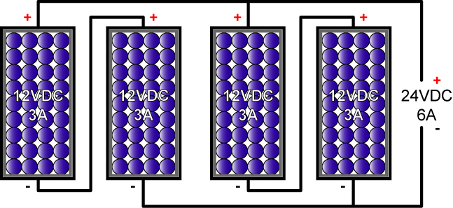

Solar Panels in Series/Parallel Combination

  - Photoelectric Control: Photoresistors are used for photoelectric control by controlling current. They are not a source of electrical energy.
    - Also called CdS (Cadmium Sulfide) cells or light dependent resistors (LDR).
    - Photoresistors change their resistance in response to the amount of light shining on them.
    - The more light striking a photoresistor, the lower its resistance.
    - Samples:

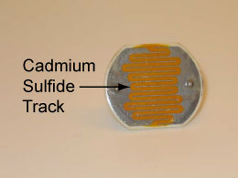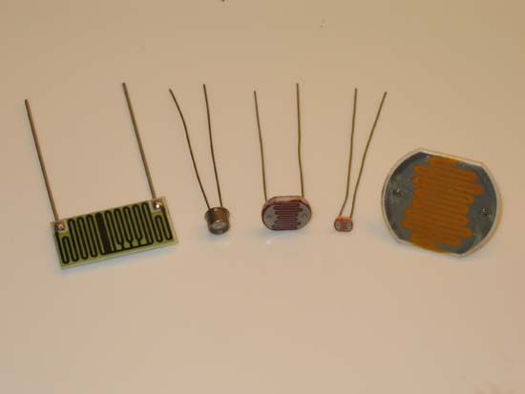

Photoresistor or Cds Photocell Assortment of Photoresistors

    - Useful for light seeking (photovore) robots, color sensors, and also as an optical switch:
      - Photovore robot video: http://www.youtube.com/watch?v=N_X4_VVxOrE
      - Color sensors reference: http://www.societyofrobots.com/sensors_color.shtml
      - Optical switch: Perform Batteries and Other Energy Sources Lab 3 - Photoresistors
  - Electrical Energy from Heat:
    - Thermocouple
      - When two dissimilar metals in contact with each other are heated, a potential difference (voltage) develops between the metals.
      - Applications:
        - Demonstrate K-type thermocouple thermometers (Taylor and Metex)
        - Temperature probe in an industrial furnace
        - Pilot light safety valve
      - Perform Batteries and Other Energy Sources Lab 4 – Thermocouples
  - Electrical Energy from Mechanical Pressure
    - Piezoelectric effect: Creating a potential difference (voltage) from the mechanical distortion of a crystal.
    - Applications:
      - Crystal microphone
      - Phonograph needle pickup
      - Engine knock sensor
    - Demonstrate piezoelectric cell (WINSCO Part # GS-711, see: http://www.winsco.com/products/genscience.htm)

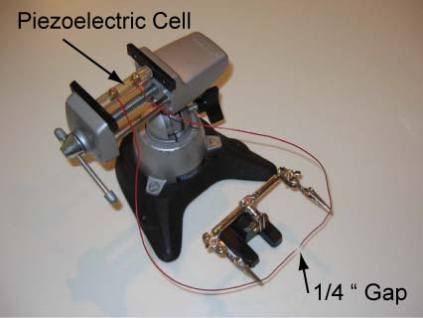

    - Fuel Cell:
      - A fuel cell is an electrochemical device that combines hydrogen and oxygen to produce electricity, with water and heat as its by-product.
      - As long as fuel is supplied, the fuel cell will continue to generate power.
      - Since the conversion of the fuel to energy takes place via an electrochemical process, not combustion, the process is clean, quiet and highly efficient – two to three times more efficient than fuel burning.
      - Efficiency, theoretically 100%
      - Applications: See: http://www.fuelcells.org/basics/apps.html
      - Demonstration using H₂ fuel cell car
    - Electricity from Magnetism
      - Generators convert rotating mechanical energy into electrical energy through magnetism.
      - Demonstrate handheld generator.
      - Covered in more detail in Week 17.
  - Related web sites:
    - http://www.allaboutcircuits.com/vol_1/chpt_11/4.html
    - http://alternative-energy-search-engine-swicki.eurekster.com/
    - http://www.freesunpower.com/solar_simulator.php
    - http://www.societyofrobots.com/schematics_photoresistor.shtml

Electronics Technology and Robotics I Week 6
Batteries and Other Energy Sources Lab 1 – Hand Battery

- Purpose: The purpose of this lab is to acquaint the student with the fact that the human body can generate an electrical potential.

- Apparatus and Materials:

  - 1 – Digital Multimeter
  - 2 – 5” x 6” Single Sided Copper Clad Circuit Board (Electronix Express # 97BS16)
  - 2 – Aluminum Plate the Size of a Palm
  - Alligator Clips with Banana Plugs

- Procedure:
  - Your skin and two different metals create a battery.
  - Connect aluminum and a copper plate to the DMM set to 2 volt range. Connect the positive lead to the copper plate.
  - Place one hand on each plate and read the meter.
  - When you touch the two metal plates, the thin film of sweat on your hands acts like the acid in a battery, reacting with the copper plate and with the aluminum plate. In one of these reactions, your hand takes negatively charged electrons away from the copper plate, leaving positive charges behind. In the other reaction, your hand gives electrons to the aluminum plate, causing it to become negatively charged. This difference in charge between the two plates creates a flow of electrical charge, or electrical current.
  - Try using the same type of metal for each plate. Place one hand on each plate and read the meter.
  - You can sometimes get a small current even between two plates made of the same metal. Each plate has a slightly different coating of oxides, salts, and oils on its surface. These coatings create slight differences in the surfaces of the metals, and these differences can produce an electrical current.

- Results:
  - Copper/aluminum maximum voltage generated: _____________ V

  - Copper/copper maximum voltage generated: _____________ V

  - Aluminum/aluminum maximum voltage generated: _____________ V

- Conclusions:
  - Which combination of metals produced the highest voltage and why?

Electronics Technology and Robotics I Week 6
Batteries and Other Energy Sources Lab 2 – Series and Parallel Batteries

- Purpose: The purpose of this lab is to acquaint the student with how voltages add when placed in series and parallel.

- Apparatus and Materials:

  - 1 – Digital Multimeter
  - 4 – AA Batteries and Battery Holders
  - TBD – Potatoes
  - TBD – #16 hot-dipped galvanized nail
  - TBD – # 6 bare copper wire
  - 1 – LED
  - Alligator Leads

- Procedure for Series Batteries:
  - Connect the four AA batteries as shown in the schematic.

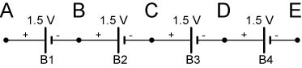

Batteries in Series

  - Measure and record the voltages V_{AB}, V_{BC}, V_{CD}, and V_{DE}.
  - Calculate the voltages V_{AC}, V_{AD}, and V_{AE} then measure and record the same voltages.
  - Compare the calculated and measured results in the conclusions.

- Results for Series Batteries:

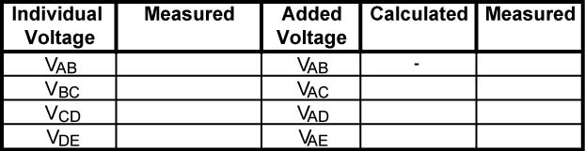

- Procedure for Parallel Batteries:
  - Connect the four AA batteries as shown in the schematic and measure V_{AB}.

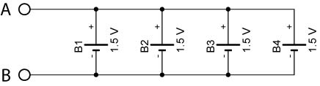
  - Remove one battery at a time and measure and record V_{AB}.
- Results for Parallel Batteries:

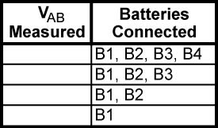

- Procedure for Parallel and Series Batteries:
  - Take a potato and insert a #16 hot-dipped galvanized nail and a # 6 bare copper wire to create a “potato cell”.
  - Experiment to find a combination of potato cells in series and parallel that provides enough voltage and current to light an LED.

- Results for Parallel and Series Batteries:
  - Draw the schematic of the battery layout used to light the LED.

- Conclusions:
  - Drycell Batteries in Series:
    - Compare the calculated and measured results in the batteries in series experiment.

    - Do the experimental results conform to the formula for batteries in series?

  - Batteries in Parallel:
    - Do the experimental results conform to the formula for batteries in parallel?
Electronics Technology and Robotics I Week 6
Batteries and Other Energy Sources Lab 3 – Photoresistors

- Purpose: The purpose of this lab is to acquaint the student with:
  - Photoresistor and how their resistance varies at different light levels and
  - A practical application for a photoresistor

- Apparatus and Materials:

  - 1 – Solderless Breadboard with 9 V Power Supply
  - 1 – Digital Multimeter
  - 3 – Cds photocells
  - 1 – 1 K Tripot
  - 2 – 100 Ohm Resistors
  - 2 – 470 Ohm Resistor
  - 2 – 2N2907A PNP Transistors
  - 2 – LED
  - 1 – DPDT Relay (Digikey # 255-1766-5-ND)

- Procedure:
  - Using the DMM, measure and record the maximum and minimum resistances for 3 photoresistors.
  - Wire the following photoresistor control circuit using a photoresistor as the sensor:

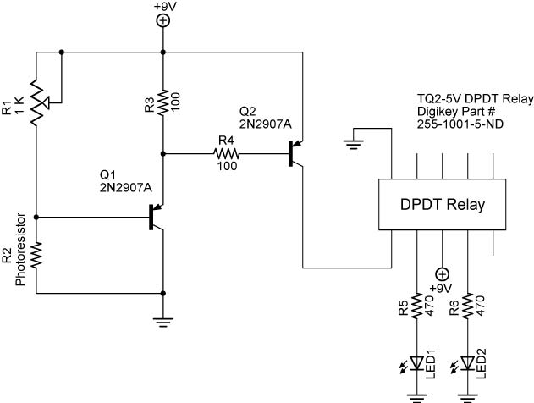

- Results:
  - Cds Photocell Resistances:

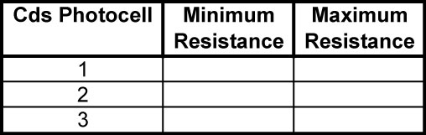

- Design Challenge:
  - Using a photoresistor, design a light controlled circuit to vary the brightness of an LED. Wire the circuit on your breadboard and draw the schematic in the results. Remember, 9 volts applied directly to an LED will burn it out.
  - Using the circuit on page 18 and two dc motors instead of the resistors and LEDs design and build a robotic car whose motion direction can be controlled using a flashlight. Tape the motors to the car.

Electronics Technology and Robotics I Week 6
Batteries and Other Energy Sources Lab 4 – Thermocouples

- Purpose: The purpose of this lab is to acquaint the student with the basic construction of a thermocouple.

- Apparatus and Materials:

  - 1 – Digital Multimeter
  - 1 – Piece of Copper Wire
  - 1 – Piece of Steel Wire
  - 1 – Pair of Pliers
  - 1 – Match or Gas Lighter

- Procedure:
  - Twist the copper and steel wires together.
  - Connect the multimeter leads to the two twisted wires. Hold the steel wire as shown to protect the positive multimeter lead.
  - Measure and record the voltage before heat is applied.
  - Apply the flame to the far end of the twisted wires to protect the negative multimeter lead. Record the voltage output of this thermocouple as heat is applied and after cool down.

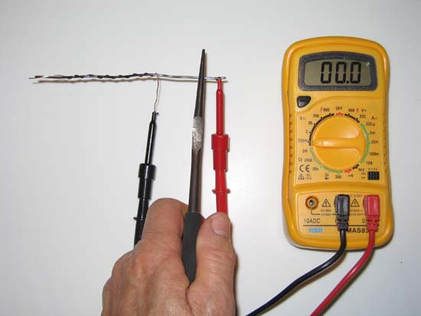

- Results:



