Ohm’s Law
Cornerstone Electronics Technology and Robotics I Week 4

- Administration:
  - Prayer
  - Review directly and inversely related terms
  - Review measuring voltage, current, and resistance w/ DMM
- Electricity and Electronics, Section 1.4, Ohm’s Law:
  - Ohm’s Law Equation: The mathematical relationship between voltage, current, and resistance.

V = I x R where:

V = voltage in volts,
I = current in amperes, and
R = resistance in ohms

From V = IR, we can derive the two equations,

I = V / R and,

R = V / I.

So voltage is directly related to current and resistance, while current is inversely related to resistance. Also, resistance is inversely related to current. Is current directly or inversely related to voltage?
  - Statement of Ohm’s Law: The current through a resistor is proportional to the potential difference between its ends, provided the temperature of the conductor remains constant.
  - See Ohm’s Law applets at:
    - http://micro.magnet.fsu.edu/electromag/java/ohmslaw/index.html
    - http://www.electricalfacts.com/Neca/Exp/Exp2/ohm1.shtml
    - http://www.falstad.com/circuit/e-ohms.html
    - http://www.angelfire.com/pa/baconbacon/page2.html
    - http://www.youtube.com/watch?v=-mHLvtGjum4&feature=related
  - Using a variable resistor and a dc power supply set up circuits that illustrate each form of Ohm’s Law while changing only one of the variables. Also have the students insert analog volt and ammeters into the circuits.
    - Use 18 volt power supply and 50 ohm, 100 watt variable resistor
    - V is directly related to I:
      - Set resistor to 25 ohms (constant)
      - Current = .12 A, voltage = 3 V
      - Current = .24 A, voltage = 6 V
    - V is directly related to R:
      - Set resistor to 20 ohms, voltage = 3 V and current = .15 A(constant)
      - Set resistor to 40 ohms, take current to .15 A, voltage = 6 V
    - I is inversely related to R:
      - Set variable resistor to 20 ohms, voltage = 6 V (constant), current = .3 A
      - Set variable resistor to 40 ohms, voltage = 6 V, current = .15 A
    - Sample Test Circuit:
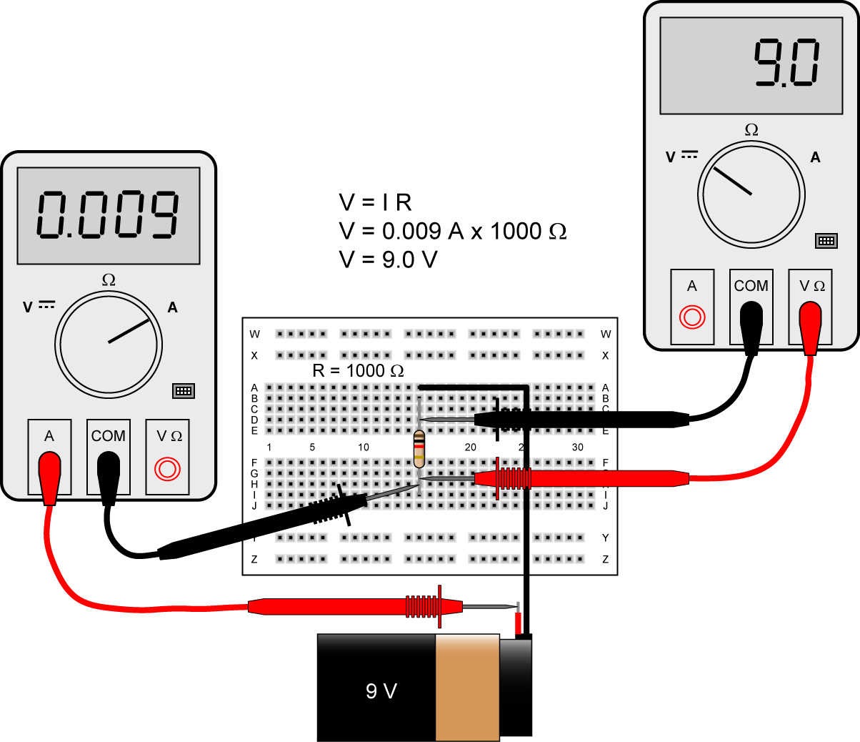

Using DMMs to Check Ohm’s Law – Ammeter on Left Is Inserted into the Circuit,
The Voltmeter on Right is Parallel to the Component (1K Resistor)

    - Perform Ohm’s Law Lab 1 – Measurements and Calculations
  - The variables used in Ohm's Law equations must be common to the same two points in the circuit under consideration. A student might mistakenly use a value for I, current, through one resistor and the value for V across a set of interconnected resistors, incorrectly thinking that they'll arrive at the resistance of that one resistor.
    - When using Ohm's Law to calculate a variable pertaining to a single component, be sure the voltage you're referencing is solely across that single component and the current you're referencing is solely through that single component and the resistance you're referencing is solely for that single component.
    - Likewise, when calculating a variable pertaining to a set of components in a circuit, be sure that the voltage, current, and resistance values are specific to that complete set of components only! A good way to remember this is to pay close attention to the two points terminating the component or set of components being analyzed, making sure that the voltage in question is across those two points, that the current in question is the electron flow from one of those points all the way to the other point, that the resistance in question is the equivalent of a single resistor between those two points.
  - A local change in one resistor value implies a global change in the circuit, i.e., a change in the operation of the entire circuit.
    - Instructor Demonstration: Ohm’s Law Lab 2 – Local/Global Circuit Changes
  - Graphing Ohm’s Law:
    - Review of Slope:
      - Slope formula given two points, (x₁,y₁) and (x₂,y₂):

m = rise / run
m = the change in y / the change in x
m = (y₂ – y₁) / (x₂ – x₁)

For example, find the slope of a line passing through the points (4, 4) and (8, 12):

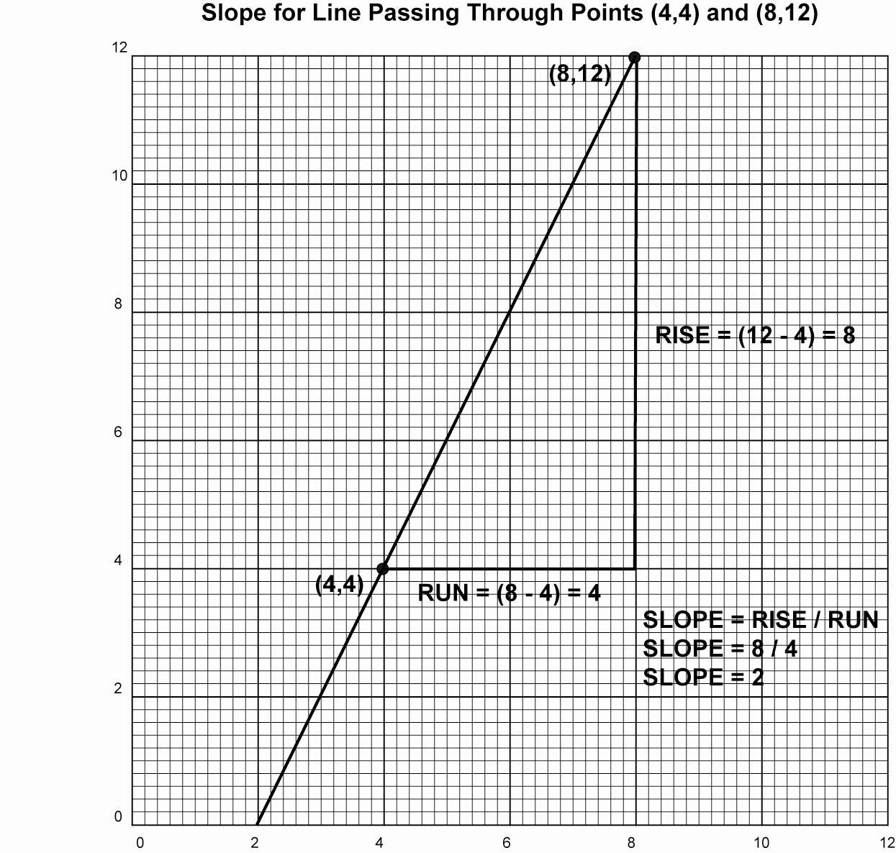

m = (y₂ – y₁) / (x₂ – x₁)
m = (12 - 4) / (8 – 4)
m = 8 / 4
m = 2

        - See slope applet at: http://www.mathwarehouse.com/algebra/linear_equation/interactive-slope.php
    - Review of Slope/Intercept Equation of a Line:
      - The equation of a line with a slope m can be written as follows:

y = mx + b

Where:
m = the slope of the line and
b = the y-intercept of the graph of the line
(the y coordinate when x = 0)

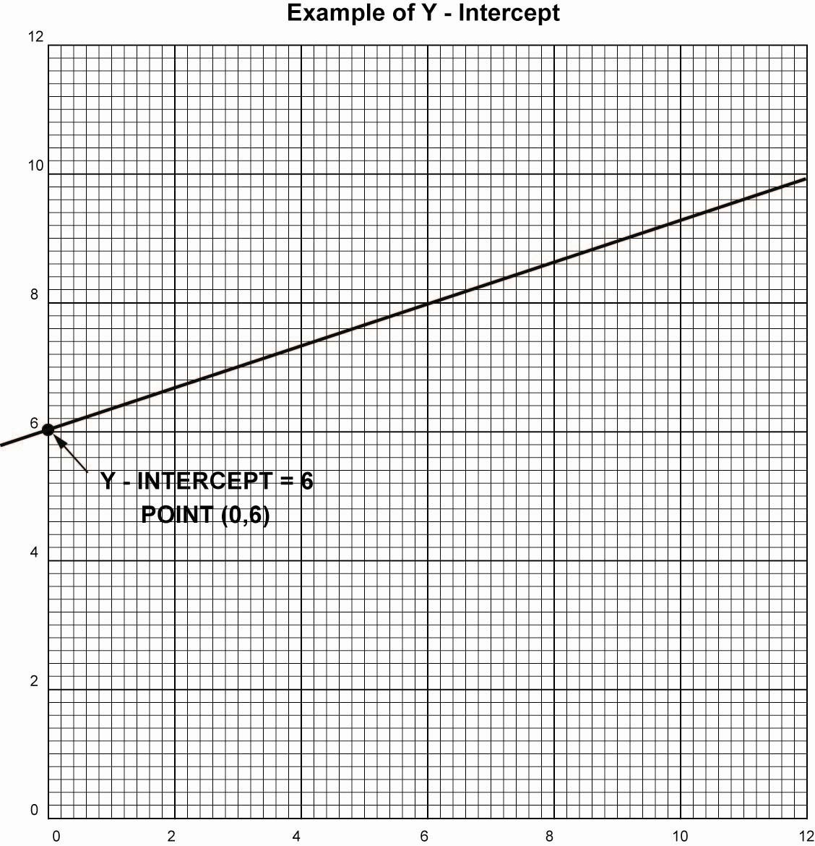

        - See slope/intercept equation of a line applet at: http://www.mathwarehouse.com/algebra/linear_equation/linear-equation-interactive-activity.php
    - Complete Ohm’s Law Lab 3 – Graphing Ohm’s Law
    - Solving for the y-intercept b in the Ohm’s Law graph:
      - Let x = 0 and the value of y will be the y intercept b, y = mx + b,
      - In our case,

V = R I + b
When I = 0, V = 0, therefore b = 0, and
V = R I, where R is the slope of the graph

  - Student Activity Sheet 2-4, Power Supply Familiarization
  - Student Activity Sheet 2-5, Verifying Ohm’s Law

- Electrical Prefixes:
  - Pay close attention to mega, kilo, milli, micro. These prefixes are the most commonly used in electronic circuitry.
  - Common Electrical Prefixes:

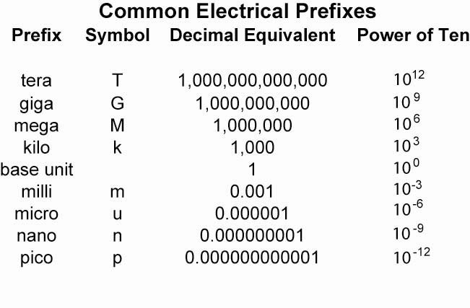
  - Number Place Values:

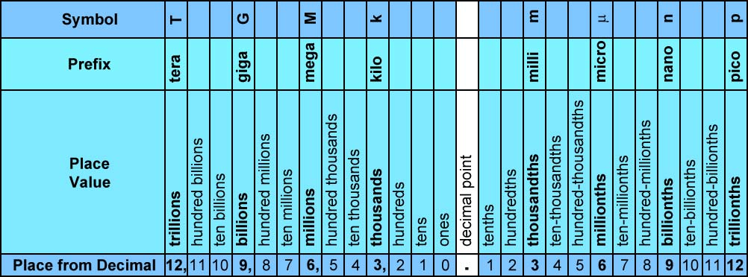

Chart for Place Values of Numbers

  - Moving the decimal point: If you are converting from a smaller prefix to a larger prefix, move the decimal point to the left. Remember:

“Left for Larger”
Larger Prefix – Move the Decimal to the Left

    - Examples:
      - Convert 50 milliamps (mA) to amperes (A). We are converting from a smaller prefix (mA) to a larger prefix (A), so we move the decimal to the left three places.

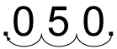

Therefore 50 mA = .05 A or 0.05 A.

      - Convert 0.22 K V to V. The conversion is from larger to smaller prefix, therefore move the decimal to the right three places.

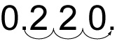

Therefore 0.22 K V = 220 V.

      - Convert 6.8 M Ω to Ω. The conversion is from larger to smaller prefix, therefore move the decimal to the right six places.

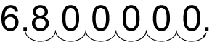

Therefore 6.8 M Ω = 6,800,000 Ω.

- Suggested Activity Sheets 1-3, 1-4, 1-6
- Related Web Sites:
  - http://en.wikipedia.org/wiki/Ohms_law
  - http://jersey.uoregon.edu/vlab/Voltage/
  - http://micro.magnet.fsu.edu/electromag/java/ohmslaw/
  - http://www.allaboutcircuits.com/vol_1/chpt_2/1.html
  - http://www.grc.nasa.gov/WWW/K-12/Sample_Projects/Ohms_Law/ohmslaw.html

Electronics Technology and Robotics I Week 4
Ohm’s Law Lab 1 – Measurements and Calculations

- Purpose: The purpose of this lab is to have the student apply Ohm’s Law to several circuits and then verify the calculated results.

- Apparatus and Materials:

  - 1 – Digital Multimeter (DMM)
  - Circuits by the Instructor

- Procedure:
  - Use Ohm’s law to analyze Circuits 1 - 6. Measure and record the quantities in the white cells of Table 1 then using Ohm’s Law, calculate the unknown quantities of the shaded cells. You’re your calculations in the text box.
  - Copy the calculated quantities from Table 1 into the shaded cells in Table 2.
  - Measure those unknown quantities using a DMM and compare with the calculated values.
  - Determine the differences in Table 2.

- Results:

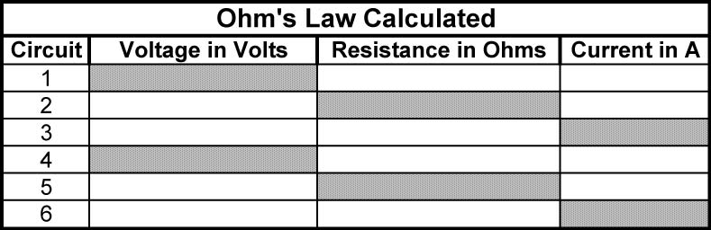
Show calculations:

1.

2.

3.

4.

5.

6.

Table 1

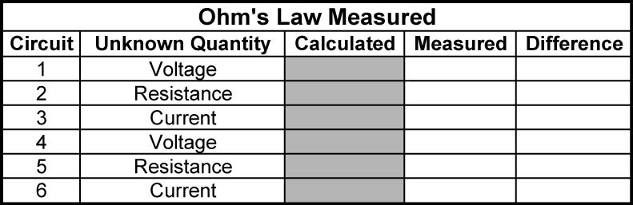

Table 2

- Conclusions:

- Challenges:
  - Design a voltage source where the single load resistance is 100 ohms and the current through the resistor is 50 mA.
Electronics Technology and Robotics I Week 4
Ohm’s Law Lab 2 – Local/Global Circuit Changes

- Purpose: The purpose of this lab is to acquaint the student with the fact that a change in the value of one circuit component can effect the operation of the entire circuit and to give the student the opportunity to wire a circuit on a solderless breadboard.

- Apparatus and Materials:

  - 1 – Solderless Breadboard with 1.5 V Power Supply
  - 1 – 6.8K Resistor
  - 1 – Photocell
  - 1 – 0.1 uF Capacitor
  - 1 – 2N3904 Transistor
  - 1 – 2N3906 Transistor
  - 1 – 8 Ohm Speaker

- Procedure:
  - Using an audible light probe circuit, demonstrate that a local change in one resistor implies a global change, i.e., change in the operation of the entire circuit.

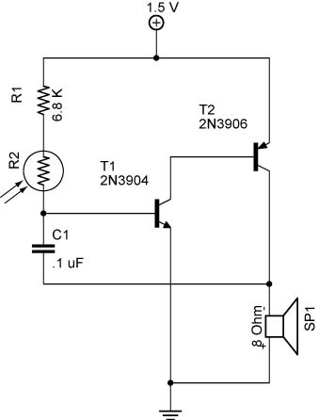

Circuit 1 - Audible Light Probe Circuit

Electronics Technology and Robotics I Week 4
Ohm’s Law Lab 3 – Graphing Ohm’s Law

- Purpose: The purpose of this lab is to acquaint the student with graphing electrical variables and how slope represents a quantity.

- Apparatus and Materials:

  - 1 – Solderless Breadboard
  - 2 – Digital Multimeters (DMM)
  - 1 – DC Power Supply
  - 1 – SPST Switch
  - 1 – 10 Ohm Resistor
  - 1 – 100 Ohm Resistor

- Procedure:
  - Wire Circuit 2 using a breadboard.
  - Change the value of the power supply from 0 to 6 volts in increments of 1 volt.
  - Using the graph provided, plot the value of the current and voltage at each voltage increment.

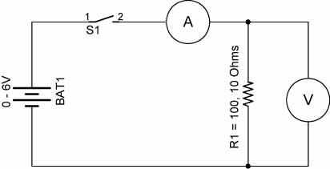

Circuit 2

- Results:

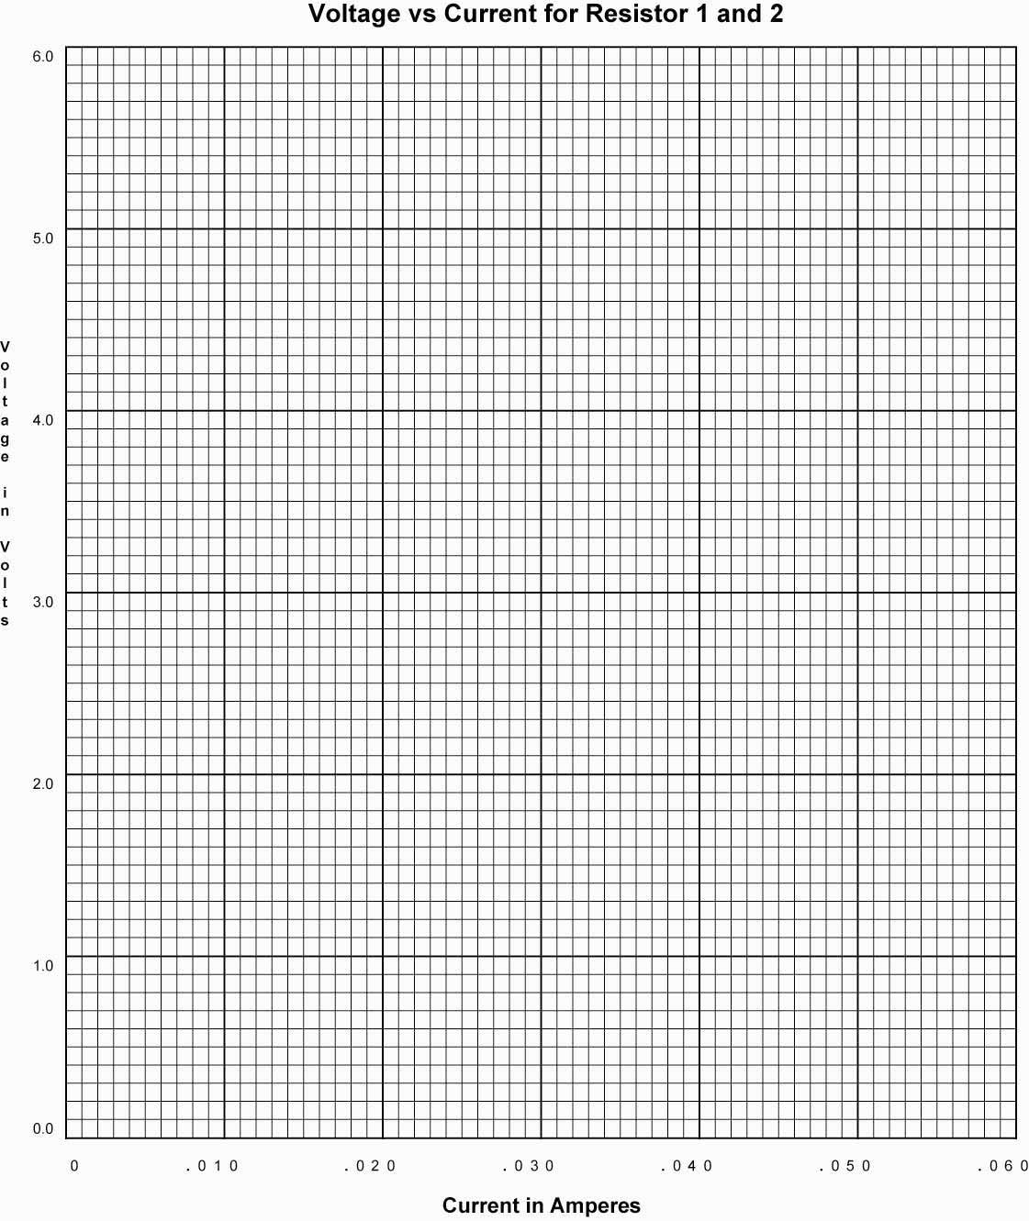

- Conclusions:

Ohm’s Law Lab 1 Circuit Values

Circuit Voltage Current Resistor Power
In volts In amps In ohms In watts
1 1.5 32 mA 47 .25
2 3.0 300 mA 10 10
3 3.0 14 mA 220 .25
4 6.0 40 mA 150 .25
5 9.0 7 mA 1200 .25
6 12.0 21 mA 560 .25
7 12.0 54 mA 220 10

