Solderless Breadboard Tutorial
Cornerstone Electronics Technology and Robotics I Week 3

- Solderless Breadboards:
  - Solderless breadboards are commonly used in experimentation or to make a prototype of a circuit before the circuit is soldered or made in mass production.
    - Experimental Prototype Circuit on Breadboard:

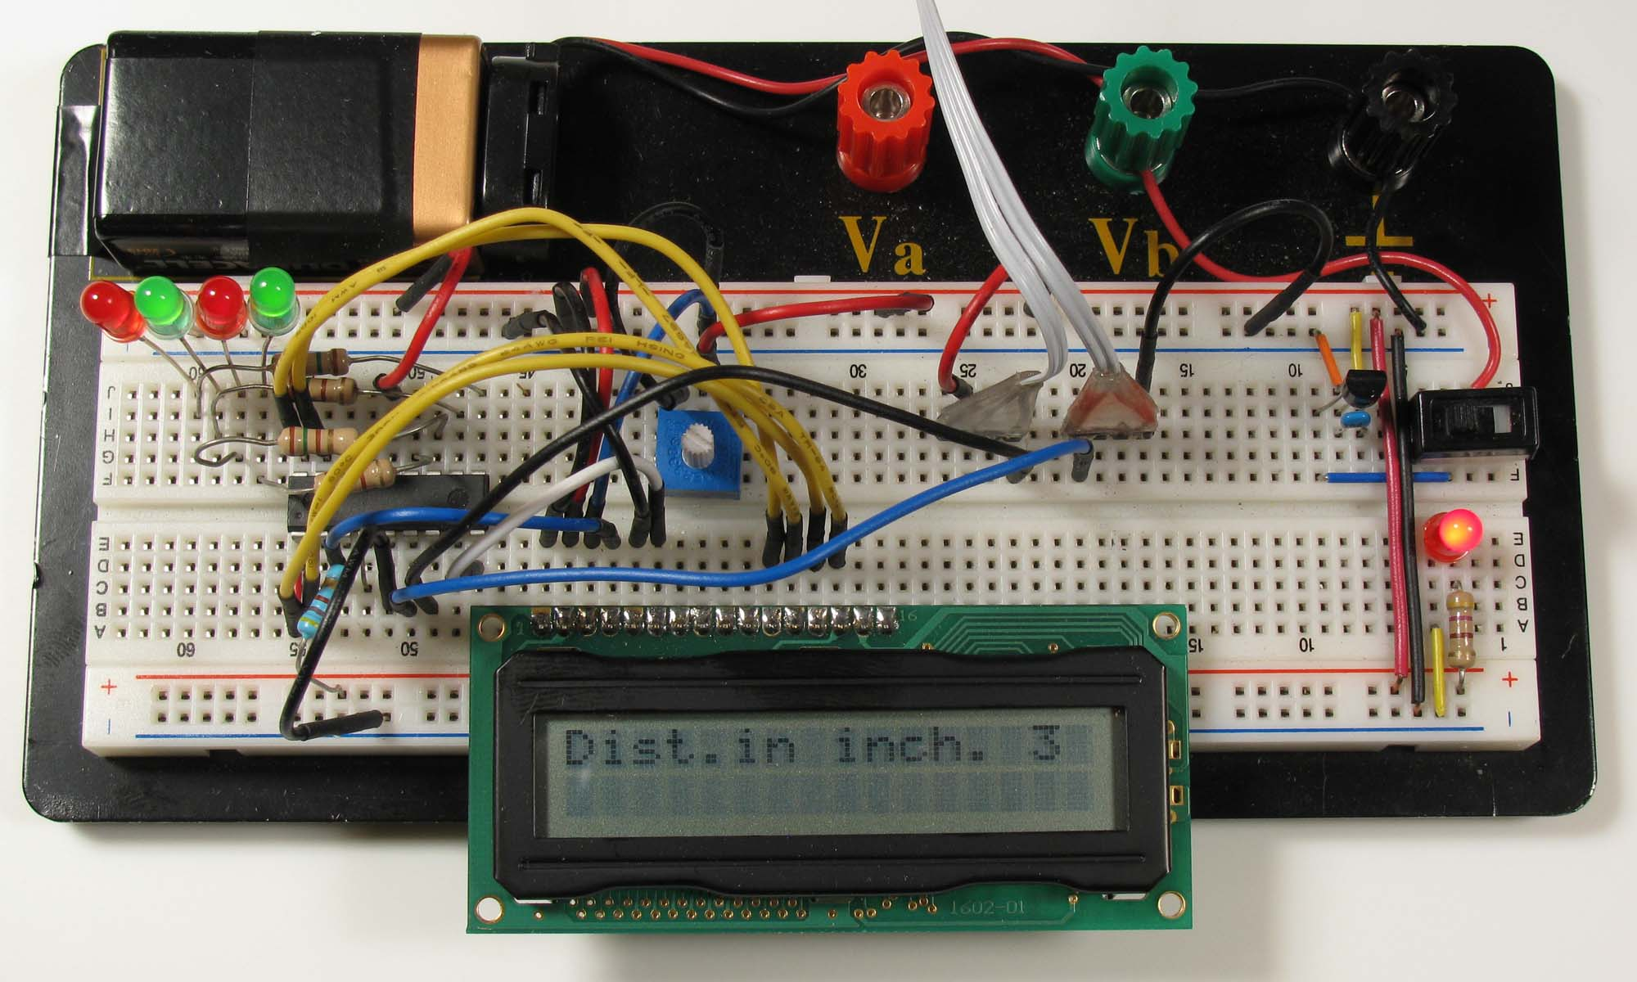

LCD Prototype Circuit on Solderless Breadboard

  - Typical Breadboard:
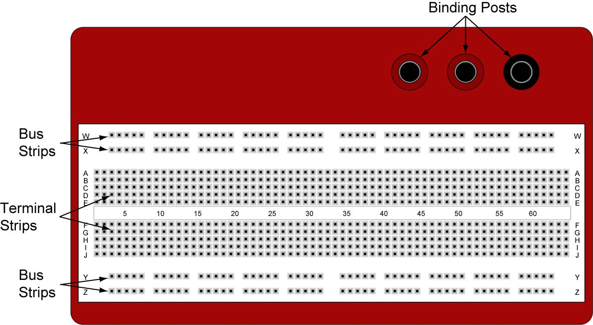

840 Pin Solderless Breadboard (http://www.digikey.com/ #922309-ND)

  - Binding Posts: Provides a way to connect an external power supply.
  - Terminal Strips: Holds the components. Five contact points in a row on each side of the notch are electrically connected.
  - Bus Strips: Provides power to the electronic components. A bus strip usually contains two columns, one for ground and one for a supply voltage.

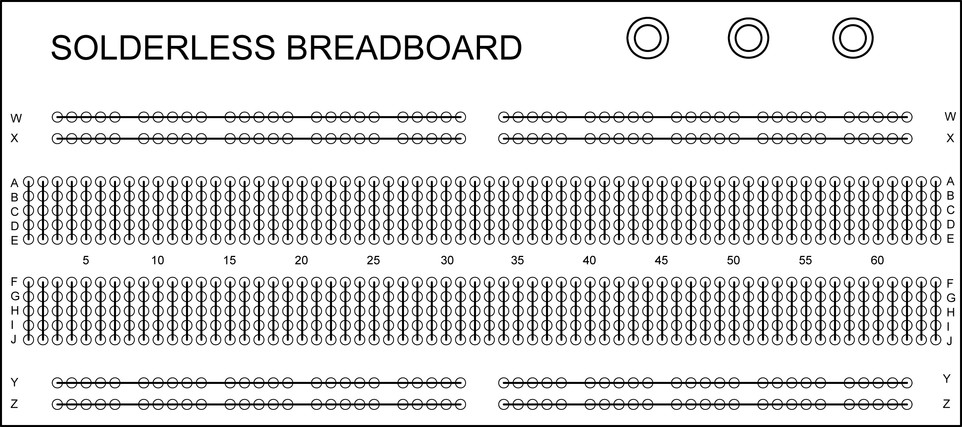

Diagram Showing Contact Points that Are Electrically Connected

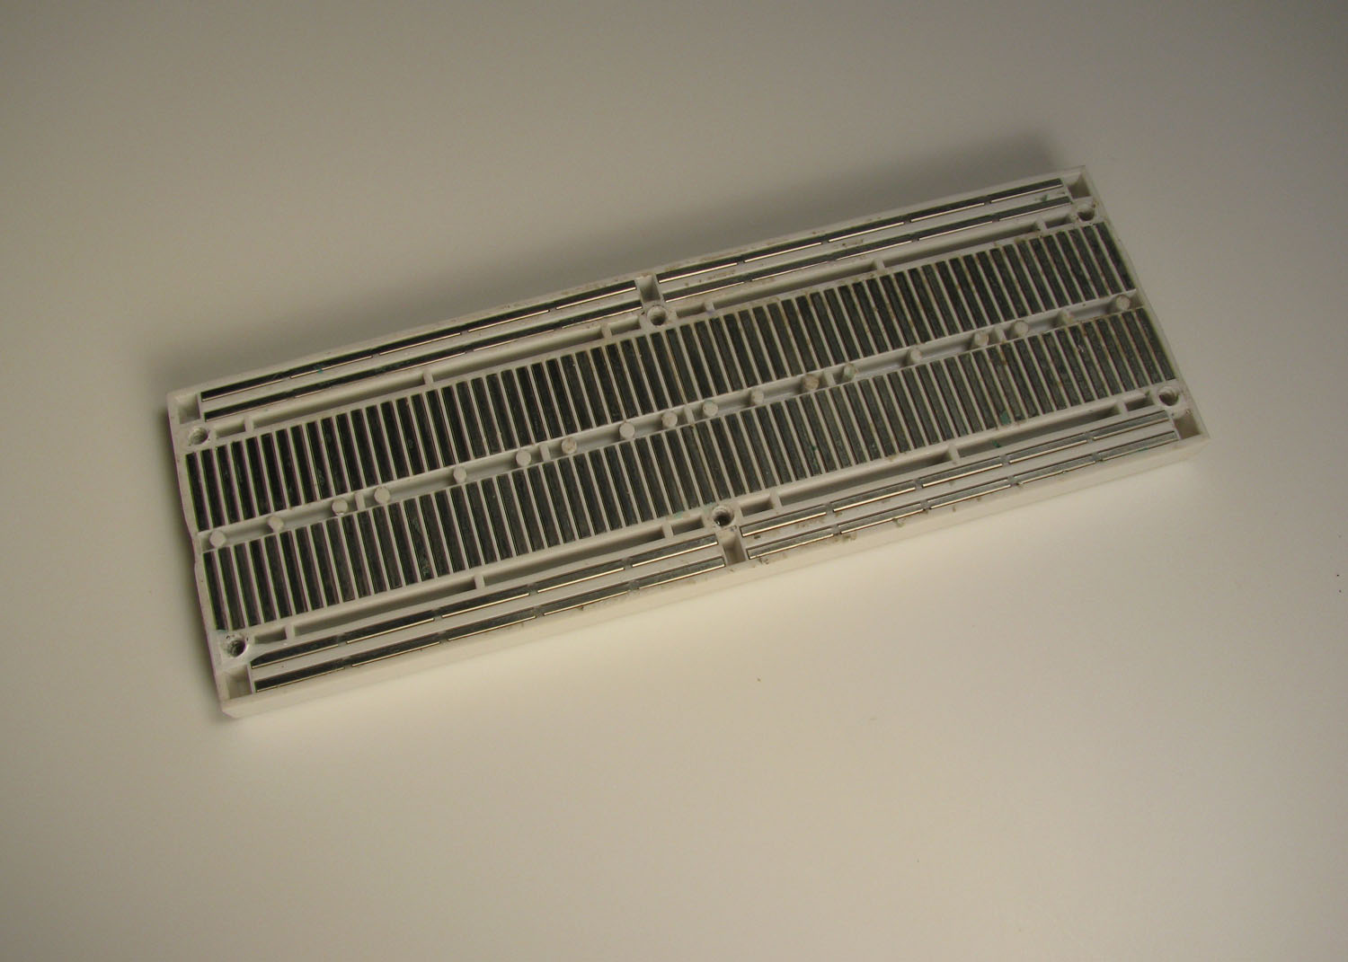

Underside of Solderless Breadboard Showing Contact Point Connections

  - Center notch is spaced to fit DIP (Dual In-line Package) integrated circuit. See below:

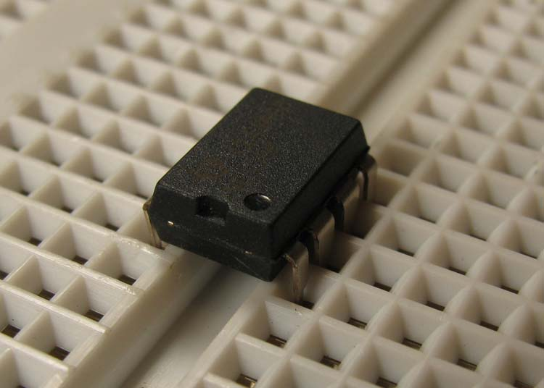

DIP Inserted over Center Notch

  - Pin Spacing: The spacing between the contact points is typically 0.1” (2.54 mm). The spacing over the center notch is 0.3” (7.62 mm),
  - Jumper Wires:
    - Homemade: Jump wire material for home-made wires should usually be 22 AWG (0.33 mm²) solid wire.
    - Jumper Wires:
      - Jumper kits come in assorted lengths of pre-stripped/preformed 22 AWG solid wire. (http://www.jameco.com #19290)
      - Reinforced Jumper Wires: Pin ends are reinforced for durability. Jameco stocks three lengths: 50 mm/1.97”, 100 mm/3.94”, and 200 mm/7.87”. (http://www.jameco.com #126360, 126342, and 126325 respectively)

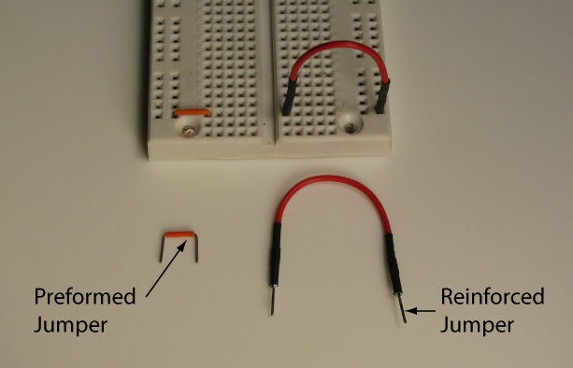

Commercial Jumper Wires

    - 0.100" Male Headers: Provides a way to connect electrical components. Headers may be soldered directly to the component or they may be soldered to component wires and encased in hot glue. See photos below.

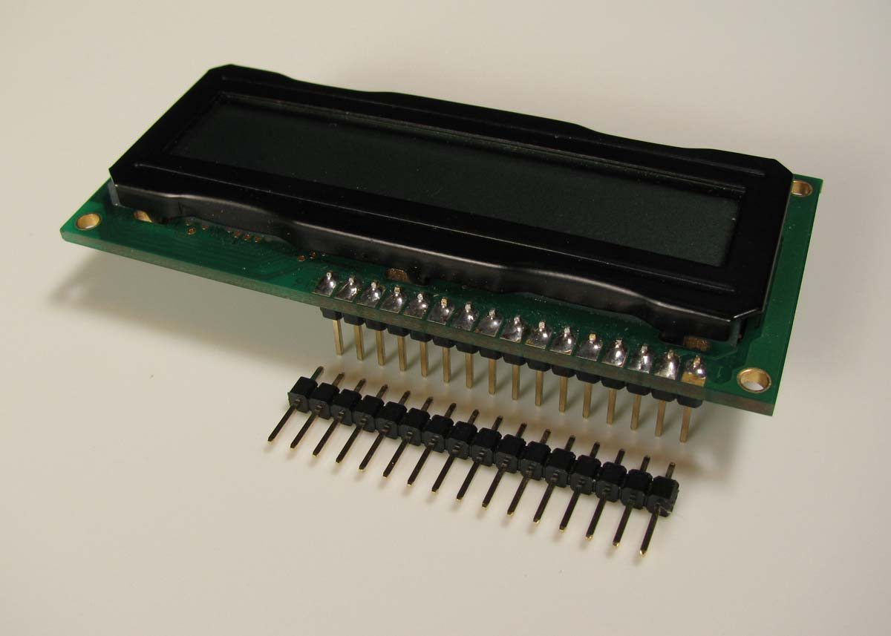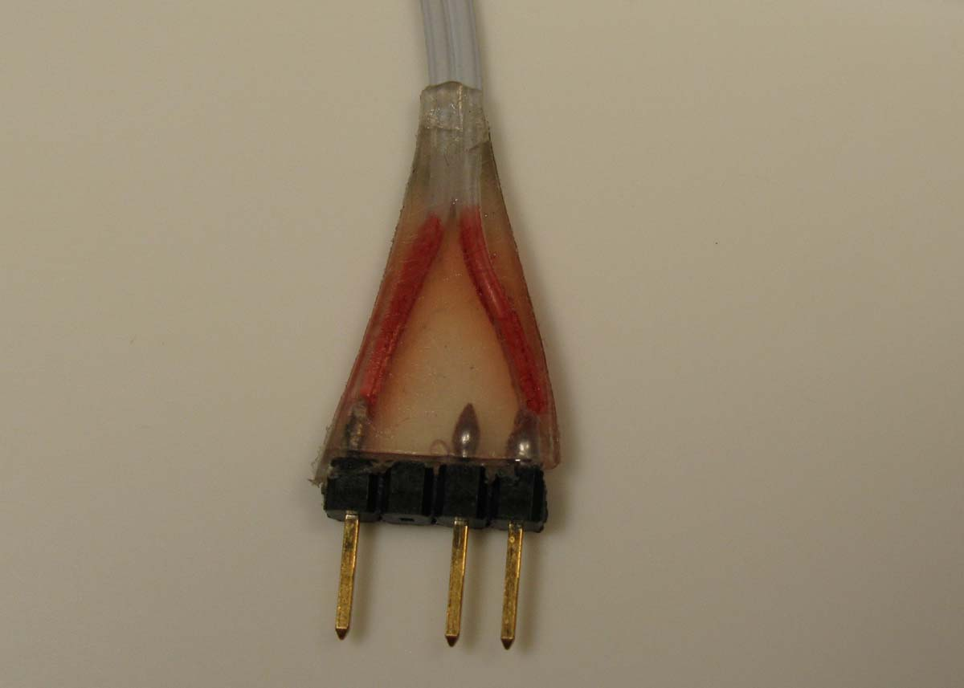

Male Header Soldered to an LCD Header Encased in Hot Glue

  - Surfboards:
    - Single-In-Line (SIP) breadboards accept discrete parts (resistors, diodes, etc.), Integrated Circuits. See other applications at: http://www.capitaladvanced.com/products.htm

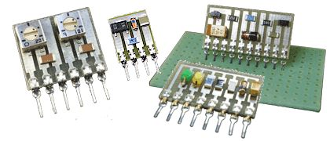

Surfboards for Discrete Parts

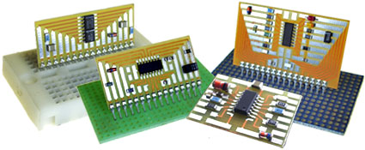

Surfboards for IC’s

  - Perform Solderless Breadboard Lab 1 – Power to the Breadboard.
Electronics Technology and Robotics I Week 3
Solderless Breadboard LAB 1 – Power to the Breadboard

- Purpose: The purpose of this lab is to have the student wire the breadboard for a +9 V and + 5 V power strips.

- Apparatus and Materials:

  - 1 – 840 Pin Solderless Breadboard (Radio Shack #276-169)
  - 1 – 1660 Pin Solderless Breadboard (Electronix Express #03MB104)
  - 1 – 9 Volt Battery
  - 1 – 9 Volt Battery Snap
  - 1 – SPDT Switch (Electronix Express #17SLDH251)
  - 1 – LED
  - 1 – 470 Ohm Resistor (Yellow, Violet, Black)
  - 1 – 78L05 Voltage Regulator
  - 1 – 0.1 uF Capacitor
  - # 22 Solid Wire (Black and Red)

- Procedure:
  - 840 Pin Solderless Breadboard:
    - Power to binding posts: Install the battery snap and wire to the binding posts.
    - Layout the switch, LED, and resistor.
    - Power to buses: Connect the binding posts to the breadboard as shown. Buses are used for distribution of electrical power to components of a system.
    - Connecting the bus strips: Connect the top two bus strips (+9 V and Ground) to the bottom two bus strips.
    - Power indicator LED: Install the final connections as shown. Be sure that the flat side of the LED is facing toward ground.
    - Check voltages at points on the two bus strips.

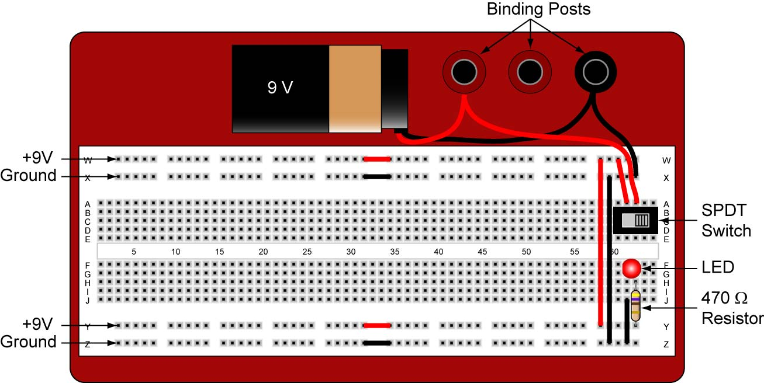

840 Pin Solderless Breadboard Setup
  - 1660 Pin Solderless Breadboard:
    - Power to binding posts: Install the battery snap and wire to the binding posts.
    - Layout the switch, LED, resistor, voltage regulator, and capacitor.
    - Power to buses: Connect the binding posts to the breadboard as shown.
    - Connecting the bus strips: Connect the top four bus strips as shown. Make sure that the only connection between the +9 V bus strips and the +5 V bus strips is the common ground connection. The only +9 V lead to the +5 V circuit is the connection to the 78L05 voltage regulator.
    - Power indicator LED: Install the final connections as shown. Be sure that the flat side of the LED is facing toward ground.
    - Check voltages at points on the four bus strips.

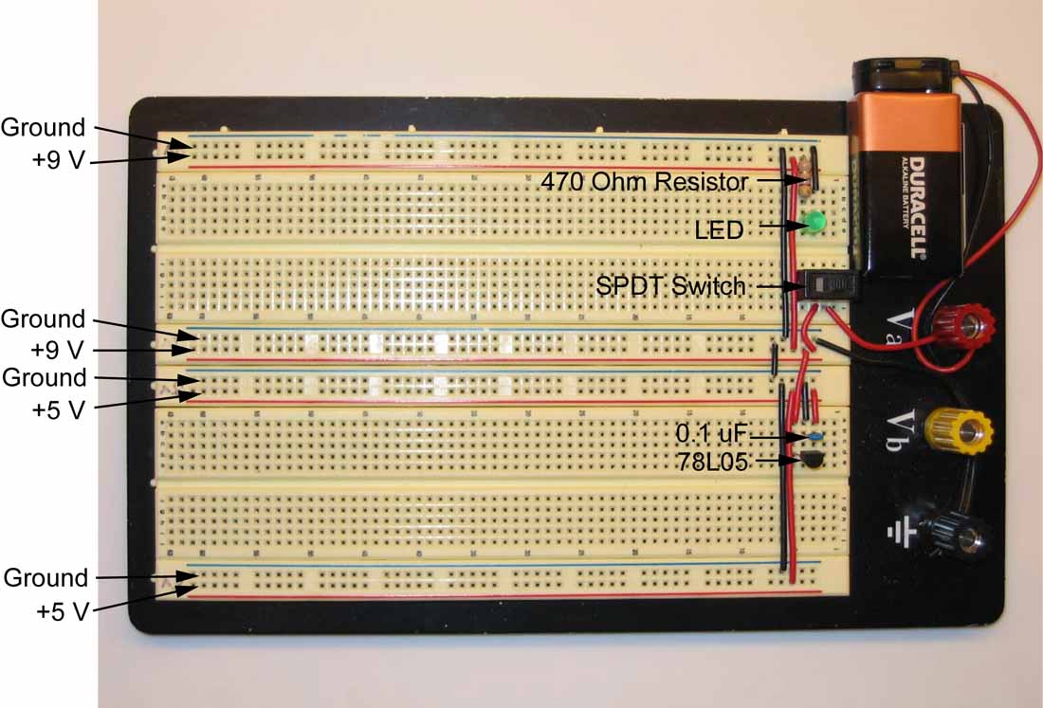

Electronics Technology and Robotics I Week 3
Solderless Breadboard LAB 2 – Hot Glued Connector

- Purpose: The purpose of this lab is to have the student construct a hot glued 0.100” header connector.

- Apparatus and Materials:

  - 1 – Hot glue gun and hot glue stick
  - 1 – Component with leads, e.g. motor or servo
  - 1 – 0.100 header

- Procedure:

