Cornerstone Electronics Technology and Robotics I Week 20
DC and AC
- Administration:
  - Prayer
  - Turn in quiz
- Direct Current (dc):
  - Direct current moves in only one direction in a circuit.
  - Though dc must travel in only one direction, its value does not necessarily have to remain constant. See Figure 1.
    - Constant dc typical of a battery or regulated dc power supply output.
    - Digital dc common when working with digital circuitry such as computers.
    - Analog dc encountered when dealing with electrical sensor outputs.
    - Pulsating dc associated with dc power supply circuits.

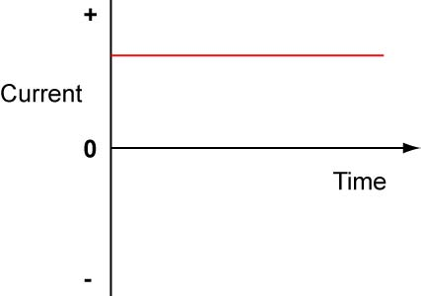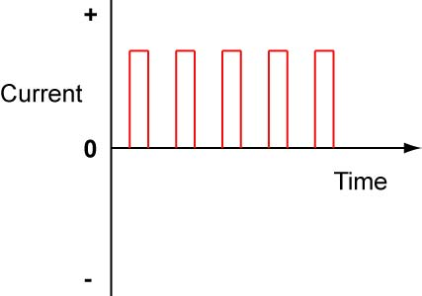
Constant dc Digital dc

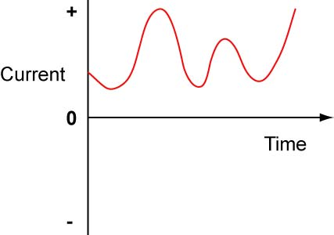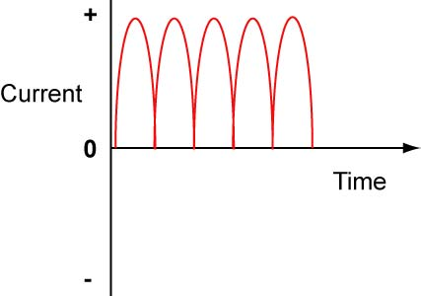
Analog dc Pulsating dc

Figure 1 Direct Current Waveforms

  - Robotic Applications:
    - Constant dc:
      - Battery or dc power supply output
    - Digital dc:
      - Pulse-Width-Modulation (PWM): Used to control motor speed.

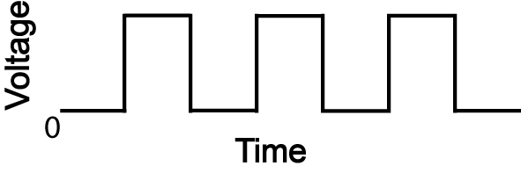

Figure 2 50 % Duty Cycle

        - Perform DC and AC Lab 1 – PWM Used to Control an LED
        - Perform DC and AC Lab 2 – PWM Used to Control a Motor
      - Pulses to control hobby servo motors:

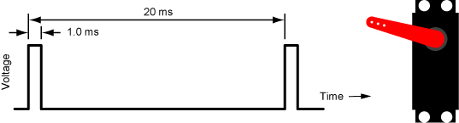

Figure 3 1.0 ms Pulse Width and Corresponding Servo Position

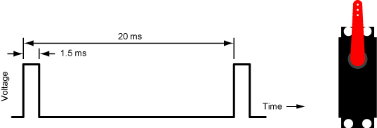

Figure 4 1.5 ms Pulse Width and Corresponding Servo Position

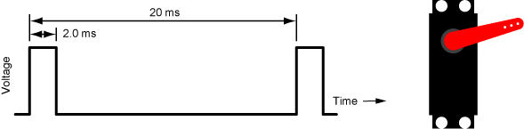

Figure 5 2.0 ms Pulse Width and Corresponding Servo Position

        - Perform DC and AC Lab 3 – Servo Pulses
    - Analog dc:
      - Output of analog sensors such as photoresistors, thermistors, and Linear Hall-Effect sensors.
- Alternating Current (ac):
  - Alternating current changes direction (polarity) and amplitude cyclically, i.e., at regular intervals.
  - Common ac waveforms:

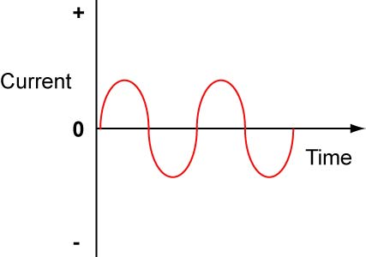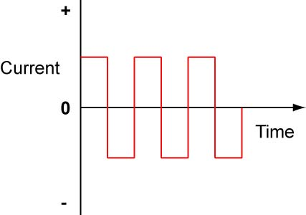

Sine Wave Square Wave

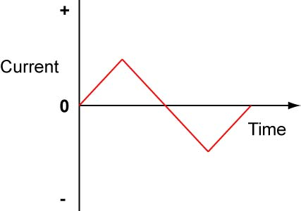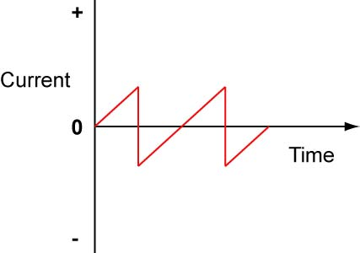

Triangle Wave Sawtooth Wave

Figure 6 Common Alternating Current Waveforms
  - Do lights blink when powered by ac? See image at: http://en.wikipedia.org/wiki/Alternating_current or http://en.wikipedia.org/wiki/File:City_lights_in_motion.jpg
  - Why do we need ac?
    - Power transfer: There are three main advantages for using ac over dc in power transmission:
      - AC generators can be larger, less complex, and cheaper to operate than dc generators.
      - Power loss in a transmission lines is created by current (I) encountering the resistance (R) in the lines and creating heat which is power (P) that is dissipated and lost. The amount of power lost is given by the formula P = I² R. The larger the current, the greater the amount of power lost in the transmission line. If you lower the current, you lower the power loss. Since P = V x I, you can send the same power P by increasing V and decreasing I. Increasing the voltage (between 200,000 and 600,000 V) along the line allows you to decrease the current and as a result, the power loss. Why does ac have an advantage over dc? AC voltage can easily be stepped up and down to a higher or lower voltage using a transformer. See: http://www.magnet.fsu.edu/education/tutorials/java/transmissionlines/
      - Converting ac to dc is a simple process compared to converting dc to ac.
    - When you differentiate or integrate a sinusoid, you get a sinusoid.
  - Faraday’s Law (electromagnetic induction):
    - Any change in the magnetic environment of a coil of wire will cause a voltage (emf) to be "induced" in the coil. No matter how the change is produced, the voltage will be generated. The change could be produced by changing the magnetic field strength, moving a magnet toward or away from the coil, moving the coil into or out of the magnetic field, rotating the coil relative to the magnet, etc.
    - Three conditions are necessary for electromagnetic induction to occur. There must be:
      - A magnetic field
      - A conductor
      - Relative motion between the magnetic field and the conductor
    - Perform the experiment in Figure 10-2 in the textbook using a DMM, a coil, and a magnet.
    - See: http://phet.colorado.edu/en/simulation/faradays-law
  - Generating an AC Voltage:
    - A generator is a device that converts mechanical energy into electrical energy.
    - A simple generator consists of a conductor rotating through a magnetic field.
    - AC generator construction:
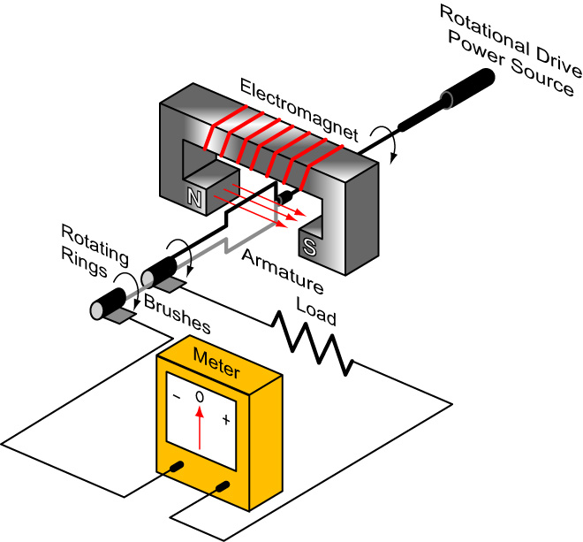

Figure 7 Simplified AC Generator Construction

    - Sinusoidal Wave Generation

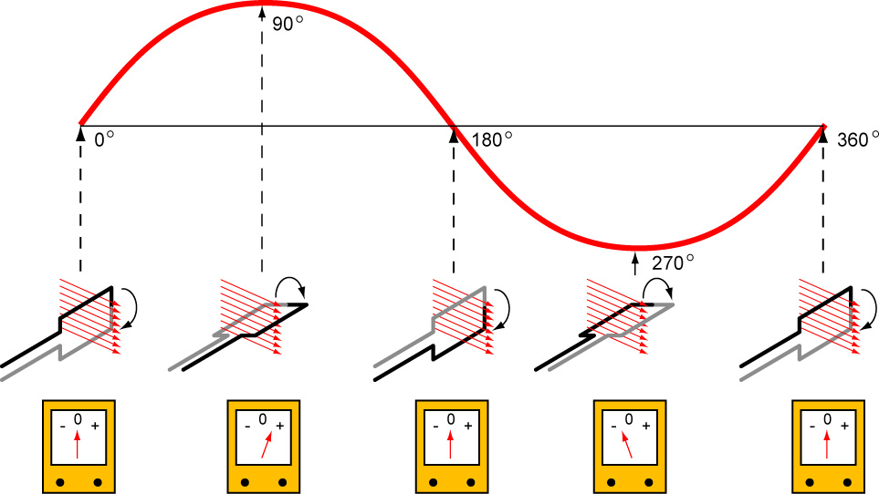

Figure 8 One Revolution of the Armature Generates One Cycle of a Sinusoidal Wave
    - See:
http://www.sciencejoywagon.com/physicszone/otherpub/wfendt/generatorengl.htm
    - When 10⁸ flux lines (1 weber) are cut by a single conductor for one second, one volt is induced.
    - When zero flux lines are cut, a zero voltage is induced.
  - Sine Wave Generation Applets:
    - Electrical: http://www.sciencejoywagon.com/physicszone/otherpub/wfendt/generatorengl.htm
    - http://www.hk-phy.org/energy/power/elect_phy/flash/ac_generator2.swf
    - http://micro.magnet.fsu.edu/electromag/java/generator/ac.html
    - Mechanical piston movement: http://www.intmath.com/Trigonometric-graphs/2_Graphs-sine-cosine-period.php
    - Mechanical spring movement: http://www.phy.ntnu.edu.tw/ntnujava/index.php?topic=148
    - Mechanical ferris wheel movement: http://mathdemos.gcsu.edu/mathdemos/sinusoidapp/sinusoidapp.html
    - Mechanical pendulum movement: http://www.ibiblio.org/links/applets/appindex/pendulum.html
    - Sine Wave Characteristics:

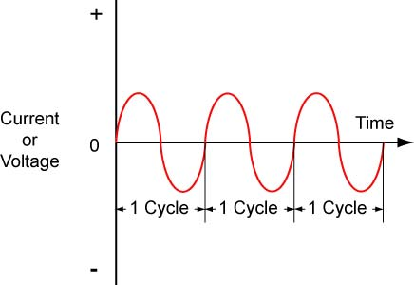 | Cycle: One repetition of a periodic waveform
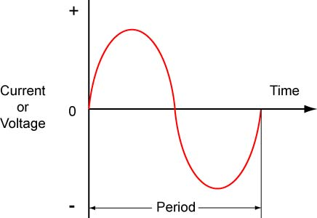 | Period (T): The time interval of one complete cycle of a periodic waveform.  T = 1 / f.
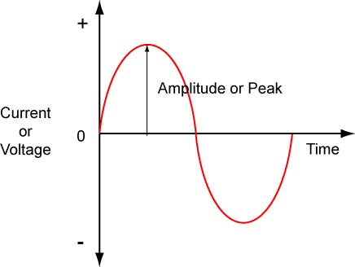 | Amplitude (V_{P} or I_{P}): The peak or maximum value of voltage or current.
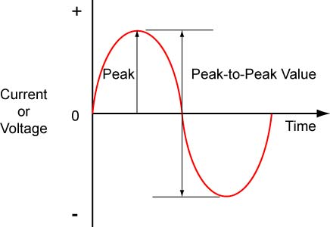 | Peak-to-Peak Value (V_{PP} or I_{PP}): The value of current or voltage measured from its minimum to its maximum values.  V_{P-P} = 2V_{P} and I_{P-P} = 2I_{P}
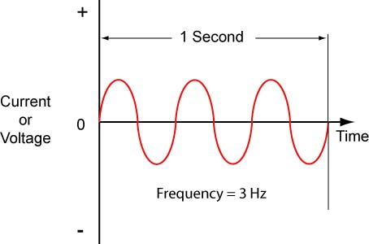 | Frequency (f): The number of cycles per second, measured in Hertz (Hz). f = 1 / T
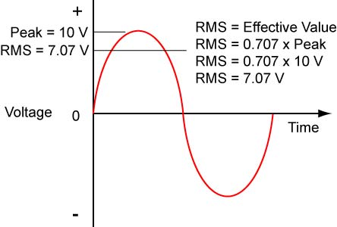 | RMS (Root-Mean-Square) or Effective Value: The value of ac voltage producing the same heating effect as an equal value of dc voltage. A 10 V ac sine wave would be as effective to supply the same amount of power to a circuit as a 7.07 V dc source. V_{RMS} = 0.707V_{P}, V_{P} = 1.414V_{RMS}

Figure 9 Sine Wave Characteristics

  - Period and Frequency:
    - Frequency: The number of cycles per second for a waveform with periodic variations, measured in Hertz (Hz).
    - Period: The time interval of one complete cycle of a periodic waveform, measured in seconds, (s).
    - Formula:
f = 1/T
Where:

f = Frequency in Hertz (Hz)
T = Period in seconds (s)
    - Phase Relationships Overview :
      - Alternating current voltages and currents can be in phase or out of phase with each other. See:
        - http://www.magnet.fsu.edu/education/tutorials/java/ac/index.html or
        - http://www.walter-fendt.de/ph11e/accircuit.htm
      - In a purely resistive ac circuit, voltage and current are in phase.
      - In a purely capacitive ac circuit, current leads voltage by 90 degrees.
      - In a purely inductive ac circuit, voltage leads current by 90 degrees.
Electronics Technology and Robotics I Week 20
DC and AC Lab 1 – PWM Used to Control an LED

- Purpose: The purpose of this lab is to demonstrate a practical application of PWM (Pulse-Width-Modulation).

- Apparatus and Materials:

  - 1 – Solderless Breadboard with 9 V Power Supply
  - 1 – Digital Multimeter
  - 1 – 100 K Tripot
  - 2 – 10 K Resistors
  - 1 – 1 K Resistor
  - 1 – 0.1 uF Capacitor
  - 1 – 0.01 uF Capacitor
  - 1 – 555 Timer IC

- Procedure:
  - Build the 555 circuit that uses PWM to control the brightness of an LED.

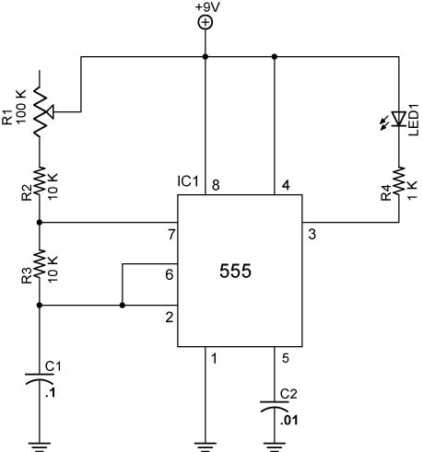

555 PWM Brightness Circuit

From 123 Robotic Experiments for the Evil Genius
(Powered by an active low on pin 3)

- Results:

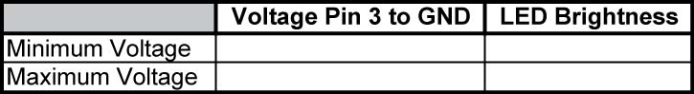

- Conclusions:
  - Why does the LED brightness increase as the voltage at pin 3 decreases?

Electronics Technology and Robotics I Week 20
DC and AC Lab 2 – PWM Used to Control a Motor

- Purpose: The purpose of this lab is to demonstrate how PWM is used to control the speed of a motor.

- Apparatus and Materials:

  - 1 – Solderless Breadboard with + 9V and +5V Power Supplies
  - 1 – Oscilloscope
  - 1 – PIC16F88 Microcontroller
  - 1 – 1 K Resistors
  - 1 – 4.7 K Resistor
  - 1 – 2N2222A NPN Transistor
  - 1 – 1N5817 Schottky Diode
  - 1 – DC Motor

- Procedure:
  - Wire the circuit pwm1 below.
  - The PIC is programmed in PicBasic Pro. The program is online at: http://cornerstonerobotics.org/code/pwm1.pdf

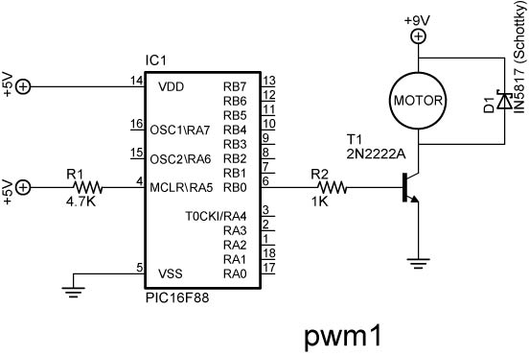

  - Place an oscilloscope probe on the output pin RB0 and observe the relationship between the waveform and the action of the motor.

Electronics Technology and Robotics I Week 20
DC and AC Lab 3 – Servo Pulses

- Purpose: The purpose of this lab is to demonstrate the pulse waveforms that control hobby servos.

- Apparatus and Materials:

  - 1 – Solderless Breadboard with +5V Power Supply
  - 1 – Oscilloscope
  - 1 – PIC16F88 Microcontroller
  - 1 – 4.7 K Resistor
  - 1 – Hobby Servo

- Procedure:
  - Wire the circuit servo1, servo2, servo3 below.
  - Note: The servo must have a separate +5V power supply from the PIC microcontroller.
  - The PIC is programmed in PicBasic Pro. The program is online at: http://cornerstonerobotics.org/code/servo3.pdf

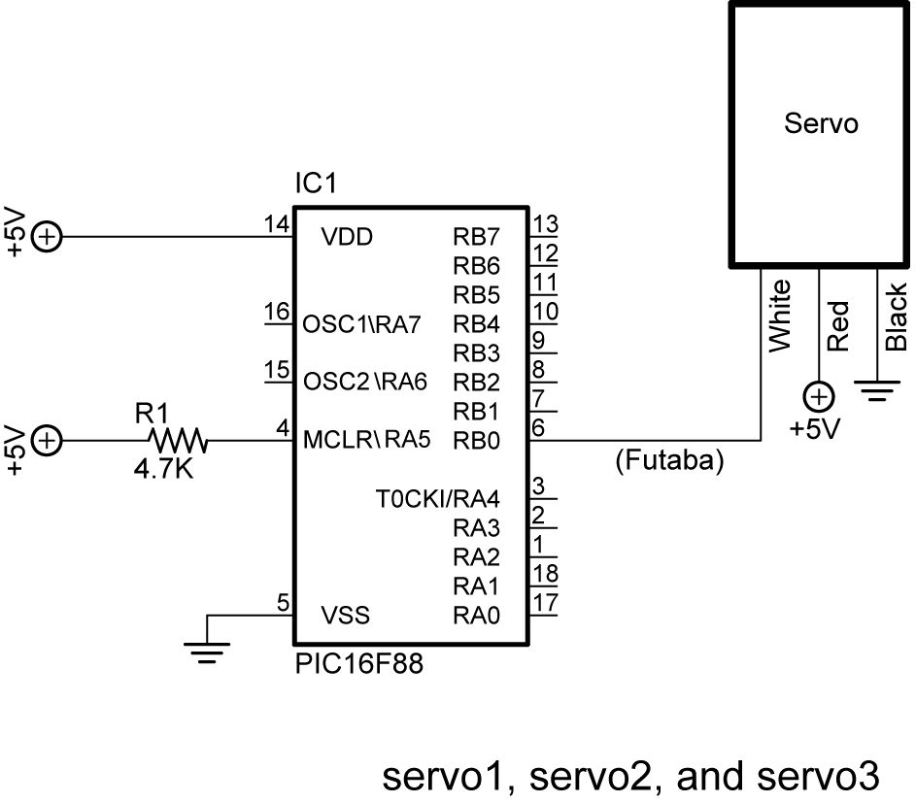

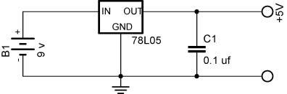

  - Place an oscilloscope probe on the output pin RB0 and observe the relationship between the waveform and the action of the servo motor.

